Information about how we support students in their learning

_____________________________________________________________________________________________________
Send Staff Guide

Contents
The spectrum of needs at 3
Passing on SEND Concerns 3
Departmental Link Teachers / Autism Accreditation 3
Additional Staff Members Supporting the SEND Team 6
SEND code of practice 7
Using Support in the classroom 8
Supporting the pupils 8
Supporting the teacher 8
Supporting the school 8
The Inclusive Teaching Checklist 9
Ofsted guidelines for teaching pupils with SEND 10
Send14: The Three Waves 11
Wave 1 11
Quality first teaching 11
NASEN Every Teacher Campaign 11
Wave 2 13
Wave 3 14
Interventions 15
Using the Core Data Sheets 15
Learning Plans & One Page Profiles 17
Seating Plans 19
Pupils’ needs at BLANK 21
The Five Point Scale 22
Access Arrangements for Examinations 23
Access Arrangements include: 23
Information and strategies for different needs 24
Dyslexia/ Dyslexic traits 24
ADHD and ADD 26
Autistic Spectrum / Asperger’s Syndrome / 27
Dyspraxia (developmental co-ordination disorder) 28
Literacy 29
Numeracy 29
Dyscalculia 30
Dysgraphia 31
Stress and anger management strategies 32
Health care plans 33
Visual difficulties 34
Hearing Difficulties 35
Further Information 36
Reading List 36
References 36

The spectrum of needs at
We have approximately ….. pupils on the SEND register, encompassing a wide range of different needs. Of these, …. have an EHCP and … have additional needs. We understand that every child is an individual, with his or her own unique range of needs that we must support. If you require any further information about a particular pupil, please do not hesitate to contact – Add Contacts. Students with EHCPs and many of those listed as additional need have key workers. Key workers are happy to go through individual pupils’ needs and support plans, as they are very knowledgeable about the pupils they support and have the advantage of seeing a range of strategies being implemented throughout the school.

Passing on SEND Concerns
Please log ALL SEND concerns and requests, including suggestions for exam access arrangements, using the SEN Helpdesk email:
senco@

Departmental Link Teachers / Autism Accreditation
Each department is invited to nominate a SEND Link Teacher / Autism Champion who will join the Autism Accreditation Quality Action Group. This group will be involved in reviewing current practice against the standards for NAS accreditation and will work closely with ……., NAS Accreditation Advisor, on formulating and leading the implementation of the action plan. This will not be a Middle Leader as meetings are likely to clash. In addition, meetings will be held throughout the year to disseminate information in both directions, to pass on concerns and good practice and to promote high quality teaching of all pupils across the curriculum.
If you have anything that you would like to be addressed at these meetings, please speak to your SEND Link Teacher / Autism Champion.

My SEND departmental Link / Autism Champion is:

___________________________________________

Introducing the SEND Team:
Picture | Name | Title and role
 |  | Learning Support Assistant
 |  | Learning Support Assistant
 |  | Learning Support Assistant
 |  | Learning Support Assistant
 |  | Learning Support Assistant
 |  | Learning Support Assistant
 |  | Learning Support Assistant
 |  | Learning Support Assistant
 |  | Learning Support Assistant
 |  | Learning Support Assistant

Additional Staff Members
Supporting the SEND Team
Designated Safeguarding Lead
Designated Safeguarding Lead
Student welfare officer Designated Safeguarding Lead (Deputy)
Attendance Officer
Student Support Assistant

SEND code of practice

The SEND code of practice published April 2014 (SEND14) made some significant changes to how we manage, identify and support pupils with Special Educational Needs.
The term ‘Additional Need – coded K’ replaced both ‘school action’ & ‘school action plus’ under SEND14. ‘Statements’ have been replaced with Education and Health Care plans, linking NHS, social care and education within a single plan. EHCPs cover birth to age 25.
The four areas of need are;
- Communication and interaction
- Cognition and learning
- Social, emotional and mental health difficulties
- Sensory and/or physical needs
The needs of pupils under these four sections are explained later in this booklet.

At BLANK we have adopted the following approach:
- Following formal assessment, pupils with EHCPs and those with complex special educational needs follow a Personalised Learning Plan, stating their needs and the support package that has been put in place. EHCPs are reviewed at least annually. The Learning Plan is reviewed at least twice each year. Learning Plans are different for each student and include teaching strategies. All staff need to be aware of students’ needs and make use of the Personal Learning Plans when planning and delivering lessons. They are easily located in the Linked Documents section of SIMS/ PARS.
- Additional Support Documents are in place for pupils identified with less complex SEND which may affect their ability to make expected progress. These contain information pertinent to supporting the individuals.
- Both the Learning Plans and the Additional Support Documents are available electronically on the linked documents area of SIMS (example follows on p20).
- All pupils on the SEND register have Learning Plans. This applies whether they are currently on the register or are being monitored. Additional Support Documents are found in ‘Linked Documents’.

Using Support in the classroom

Learning support in the classroom can offer support in a number of ways:
- Supporting the pupils
- Supporting the teacher
- Supporting the school

Supporting the pupils
- Developing an understanding of the specific needs of the SEND pupils
- Establishing a supportive relationship with pupils and developing methods of promoting and reinforcing their self-esteem
- Helping pupils to learn as effectively as possible in both group situations and on their own
- Clarifying and explaining instructions
- Ensuring the pupils are able to use the materials and equipment needed
- Motivating and encouraging pupils when necessary
- Assisting them in weak areas such as literacy, behaviour and presentation skills etc.
- Helping pupils to stay on task and finish the work set
- Helping pupils organise and complete their homework during after-school homework club.

Supporting the teacher
- Providing regular feedback about pupils to the class teacher
- Liaising with the class teacher to devise differentiated learning activities
- Contributing to the maintenance of pupils’ records

Supporting the school
- Contributing to established links between home and school
- Liaising with other members of the team to support SEND pupils
- Attending relevant in-service training
- Being aware of and following established school procedures.

The Inclusive Teaching Checklist
How inclusive and accessible are your lessons?
How can you better meet the needs of all your pupils?
How many of these strategies do you routinely plan and use in your teaching?
Inclusive Teaching Checklist | 
Use a calm, even tone of voice when talking. Do not shout.
Interactive strategies e.g. students having cards to hold up or mini-whiteboards
Use of visual and tangible aids e.g. real objects, signs or symbols, photographs, computer animations
Student groupings used so students are able to draw on each other’s strengths and skills
New or difficult vocabulary is clarified, written up, displayed and returned to
Questions are pitched so that they challenge all students at all levels
Time and support is given before responses are required e.g. personal thinking time, partner talk
Tasks are modelled then related to success criteria
Different resources are available on tables/working walls e.g. word lists, dictionaries of terms, glossaries, visual prompts, scaffolds
Scaffolding is used to support learners e.g. problem-solving grids, talk and writing frames, clue cards
Arrangements are in place to ensure that all students can access written text or instructions e.g. buddying, adult support, taping, simplified version.
There are planned alternative recording methods where appropriate for some students and/or tasks. Where learning plans identify that a pupil would find handouts that they can annotate helpful to progress, please supply them. Reduce to an absolute minimum the need to copy from the board. Allow students to photograph.
Homework tasks are differentiated to meet the needs of specific learners and support is given when recording the task. Homework is on Insight.

Ofsted guidelines for teaching pupils with SEND
Every teacher is a teacher of SEND.
The Special Education Needs and disability review states that the following characteristics are found in the best lessons observed. Although these features are true for good teaching generally, they are particularly true for the teaching of disabled children and young people and those with Special Educational Needs.
Children and young people learn best when:
- They look to the teacher for their main learning and to the support staff for support.
- Assessment is secure, continuous and acted upon.
- Teachers plan opportunities for pupils to collaborate, work things out for themselves and apply what they have learnt to different situations.
- Teachers’ subject knowledge is good
- Teachers understand pupils’ needs and how to help them.
- Lesson structures are clear and familiar but allow for adaptation and flexibility.
- All aspects of a lesson are well thought out and any adaptations needed are made without fuss to ensure that everyone in class has access.
- Teachers present information in different ways to ensure all children and young people understand.
- Teachers adjust the pace of the lesson to reflect how children and young people are learning.
- The staff clearly understand the difference between ensuring that children and young people are learning and keeping them occupied.
- Respect for individuals is reflected in high expectations for their achievement.
- The effectiveness of specific types of support is understood and the right support put in place at the right time.

The Children and Families Act of 2014 was passed as law in March 2014 and reforms legislation relating to the following areas:
- adoption and children in care
- aspects of the family justice system
- children and young people with special educational needs
- the Office of the Children’s Commissioner for England
- statutory rights to leave and pay for parents and adopters
- time off work for ante-natal care
- the right to request flexible working

Send14: The Three Waves

SEND14 structures support / intervention into three waves (National Strategy: Three Waves of Intervention):

Wave 1
Wave 1 describes what we offer to all pupils: the effective inclusion of all pupils in high-quality everyday personalised teaching. This is known as Quality First teaching.

Quality first teaching
Quality First teaching as part of ‘Narrowing the Gap’ agenda has key characteristics embedded within the BLANK Model for Learning and inclusive teaching checklist, including:
- Highly focused lesson design with sharp objectives
- High demands of pupil involvement and engagement with their learning
- High levels of interaction for all pupils
- Appropriate use of teacher questioning, modelling and explaining
- An emphasis on learning through dialogue, with regular opportunities for pupils to talk both individually and in groups
- An expectation that pupils will accept responsibility for their own learning and work independently
- Regular use of encouragement and authentic praise to engage and motivate pupils.

NASEN Every Teacher Campaign
The Every Teacher campaign by The National Association for Special Education Needs (NASEN) has five key messages:
- Every teacher is a teacher of children with special educational needs and is responsible for every pupil in their class.
- Every teacher is accountable for every pupil’s progress.
- Every teacher is entitled to high quality professional development.
- Every teacher should understand the individual needs of all their pupils.
- Every teacher should have the support of a qualified and experienced SEND team.

Examples:
- Clear objectives shared with all pupils at the start of the lesson and returned to during or at the end of the lesson
- New vocabulary carefully explained and put into context
- Lively, interactive teaching styles deployed when appropriate
- Visual and kinaesthetic learning methods deployed whenever possible as well as auditory/ verbal learning.
- Carefully planned long-term differentiation.
Quality teaching of this nature is the best way to reduce, from the outset, the number of children needing additional help with their learning or behaviour.

Wave 2
Wave 2 outlines the additional interventions for those students whose needs fall into one or more of the SEND14 categories (see SEND Code of Practice, above).

Wave 2 Interventions at BLANK include:
- Accelerated Maths  - Additional ICT access / provision to support class learning  - Anger management interventions  - Attendance support programmes  - Breakfast club  - Differentiated class work and homework  - Work with our safeguarding and student welfare officer  - Extra-Curricular activities access  - GCSE preparation support  - Handwriting support  - Homework support / club  - Individualised learning programme  - Key worker support  - Literacy catch-up interventions including Nessy & Lexia, IDL  - Maths mentoring and catch-up  - Peer mentoring  - Progress monitoring  - Pupil Profile document to share strategies with staff | - Quiet lunch club  - Reasonable adjustments support  - Referral to Early Help Network  - Referral to HSLW  - Referral to SENCO  - Regular communication with parents  - Relevant rewards systems  - Report system and behaviour logs  - Small group learning programmes  - Social skills intervention  - Specialist study support  - Speech and Language learning programmes  - Star Reader  - Study skills intervention  - Targeted in-class shared support  - Time-out support/ Support Room  - Transition management and planning with SENCO

Wave 3
Wave 3 outlines the highly personalised interventions overseen by the SENCO / Lead Teacher for students whose needs fall into one or more of the four SEND14 categories outlined above.

Wave 3 Interventions include:

In House Provision:
- 1:1 or small group Literacy support  - 1:1 or small group LSA support  - 1:1 or small group Numeracy support  - 1:1 or small group teaching  - Access arrangements for exam concessions  - Access to specialised ICT support  - Access to alternative provision  e.g. Vocational KS4 provision Asdan courses  - Detailed inductions and transitions programmes  - Inclusion strategies  - Individual rewards systems | - Key Stage 4 Options guidance  - Key workers  - Mentoring support  - Modified timetable  - Personalised Programme of Learning (PPL)  - Phonics programmes  - Pupil Profiles  - Regular monitoring of intervention impact  - SEND Pathways advice  - Social Articles  - Statutory reviews of progress  - Strategies for teachers  - Support from Student Welfare Officer  - Support Room  - Visual timetables
Specialist Interventions from Outside Providers:
- Specialist Teaching Team
- Art Therapy & ASD Outreach
- CAMHS - Child and Adolescent Mental Health
- Early Help Network
- Education Psychologist
- Educational Welfare Officer
- Chance 2 Be Programme – Therapeutic Intervention
- Occupational Therapy (OT)
- Speech and Language Therapy (SALT)

Interventions

Interventions help individual students catch up with their peers. Interventions take place in small groups or individually and are normally for a number of sessions (half a term or a full term).
Current interventions include help for students with their:
- Literacy – reading, spelling, comprehension and exam technique
- Numeracy
- Dyslexia support
- Spelling
- Handwriting
- Anger management
- Offsite general educational interventions

Interventions are analysed to ensure they are providing positive impact and are logged using the Interventions Module on SIMS.
It is possible to see which interventions have been in place for a particular student by right clicking the ‘Name’ area on a register and choosing to show interventions and then hovering the mouse over the intervention next to the student’s name on the register. A detailed report can be accessed by clicking ‘Intervention Report’ in the right hand panel of a student’s SIMS page.

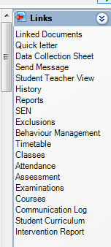

Using the Core Data Sheets
The core data sheets contain a wealth of data about the students you teach and are designed to help you differentiate effectively to meet the needs of the pupils you teach:
- Gender
- Free School Meals Y=currently entitled
- Pupil Premium Y=currently entitled
- SEND Status
(E = EHCP, S = Statement, K = Additional Need, N = no SEND)
- A brief description of SEND need
- Teacher Assessed Maths KS2 score}
- Teacher Assessed Science KS2 score} These will be different for students
- Teacher Assessed English KS2 score} joining us from September 2016
- MidYIS Vocabulary Band Year 7
- MidYIS Maths Standardised
- MidYIS Maths Band Year 7
MidYIS strands are a useful guide to the strengths and weaknesses of individuals.
- MidYIS Non Verbal Band Year 7
- MidYIS Proof Reading Score
- MidYIS Proof Reading Band Year 7
- MidYIS Processing Score
- MidYIS Processing Band Year 7
- MidYIS Skills Standardised
MidYIS overall figures give an indicator of ability.
A score of 100 = average. 125 = G & T
- MidYIS Skills Band Year 7
- MidYIS Overall Standardised
- MidYIS Overall Band Year 7
- Year 7 Reading Age
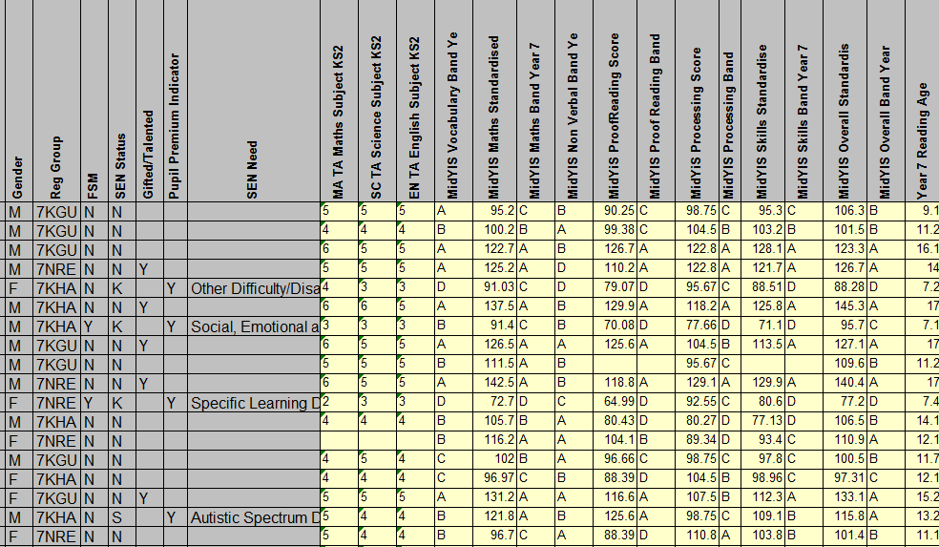

Learning Plans & One Page Profiles
All pupils with EHCP and many SEND Support students have a personalised Learning Plan, containing key SEND information to assist teachers. Personalised Learning Plans are now also available for other vulnerable pupils.
You can find these Learning Plans using SIMS or PARS. They are attached documents under the SEN tab (screen shots follow). Depending on the student, there may be other useful attached documents in the same area (for the example below H has a One Page Profile (written by H about how he learns best) and a document about supporting pupils with ASD.

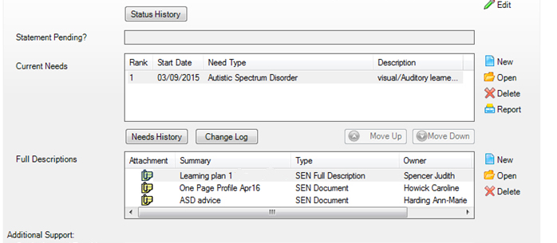

Learning plan

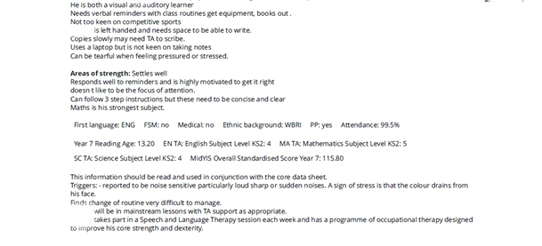

One Page Profiles are written from the pupil’s point of view – what they enjoy, what they find hard and how they prefer to be supported.
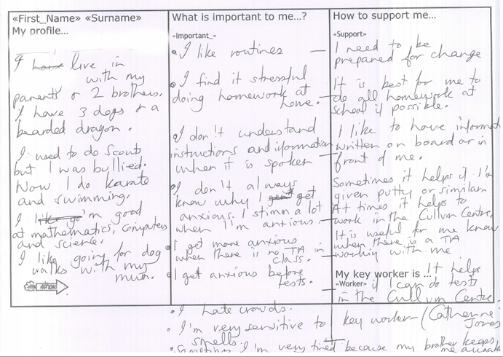

These are key documents in supporting pupil voice and in making essential information available to staff to assist them in planning and supporting these pupils in class.

Seating Plans
Please use PARS Seating Planner to generate a seating plan for each of your teaching groups.

Creating layout.
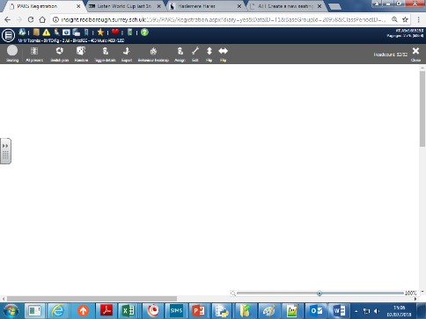
Choose the register for your group. Click SEATING in the top left-hand corner.
If you have no room layout made, you will see this. Choose EDIT (no edit button? e-mail …..).
You will then get gridlines, and the add desk/chair tool - you can also use the AUTO LAYOUT (recommended).

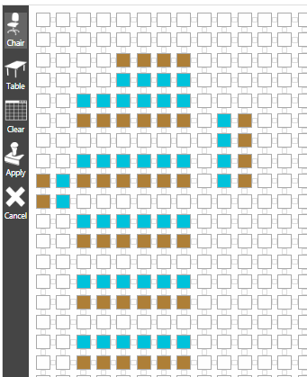
Add tables and chairs (you must add chairs) to your room then choose APPLY when you are happy. Once you have saved your plan you are ready to Assign students.

ANYONE TEACHING IN THIS ROOM CAN USE THE DESIGN YOU HAVE MADE

Assign students to seats
On your prepared seating plan, use ASSIGN to add students- these will be pulled from the PARS database… It will give you these options - based on data stored in PARS:
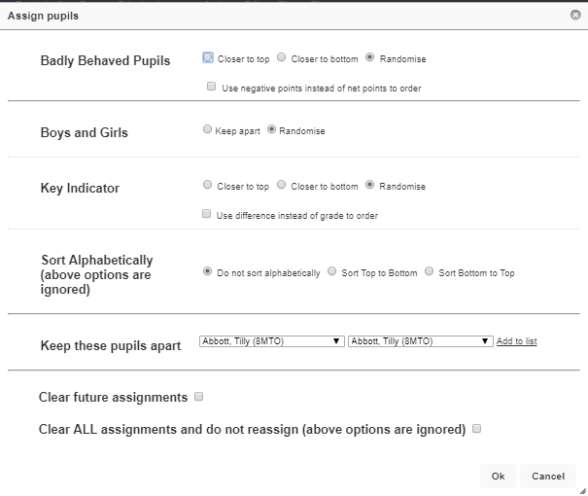
Use these check boxes to control the allocation of students.
The Key indicator is their grade in your subject.
You can specify children to keep apart - choose names from drop down, then ADD TO LIST.
I am not sure what the bottom 2 boxes do- I would leave them blank.
Click OK to allocate following your chosen rules—you can do this several times!

You can finish off manually once you have done this—completing those last minute tweaks!
Do this by clicking the white cross in blue circle, which will open this menu:

the white cross on green background enables you to move the student, the blue arrows to swap with someone else. Click on the blue arrow, and green “destination” boxes will appear on the screen. Click the green box you wish to swap, and they will swap.

To PRINT or SAVE your seating plan, click EXPORT, then SAVE AS. It will save as an image file (.PNG), which you can insert into a .doc file for easy reference.

The Dice is a RANDOMISE button, which will randomly select a student.

Each time you teach that group in the room you have edited the seating plan will be created

If you wish, you can register and complete behaviour entry from the seating plan view in PARS.

Pupils’ needs at BLANK

The list below refers to BLANK students on roll from September 2018.
This is not an exhaustive list and we may become aware of other needs as the year progresses.
- Dyslexia
- ADHD and ADD – Attention Deficit Hyperactivity disorder
- Asperger’s and Autism
- Dyspraxia – Developmental co-ordination disorder
- Literacy
- Numeracy
- Dyscalculia
- Dysgraphia
- Pupils in a state of stress and/or anger management
- Visual Difficulties
- Hearing Difficulties
- Muscular Dystrophy
- Cerebral Palsy
- Cystic Fibrosis
- Severe allergies e.g. nut allergy – anaphylaxis – require epipen and careful mealtime management
- Omphalocele – internal organs displaced – high risk of bowel occlusion
- Galactosaemia – rare metabolic liver condition – severe lactose allergy
- Reflex Syncope – blackouts without warning
- Congenital Heart Conditions
- Growth hormone deficiency – requires daily injections

The Five Point Scale

5 | The five-point scale is a tool we use with young people to help them to identify and self-regulate their emotional state. Through modelling the language of emotional intelligence we can encourage the young person to recognise and identify the emotion they are feeling, to rate it 1 to 5 and then to engage with strategies that will allow them to de-escalate away from a meltdown or explosion. In order to access learning a young person needs to be, ideally at a 1 or a 2, if the young person gets to 4 or 5 they will not able to access their learning.  We need to encourage students to identify and practise appropriate strategies that will enable them to self-regulate and, when necessary, bring themselves down through the five-point scale to a point where they can learn again. Strategies may include movement breaks, fiddle toys, finding a quiet place, reading for a short period, deep breathing, counting etc.  The scale can also be applied to staff!  When we are aware of our own emotional state we can be mindful of its impact on our interactions with the young people in our care. It is worth noting that those with ASD are often hypersensitive to the moods of others and are likely to notice our emotional state even if we try to mask it!
4
3
2
1

Access Arrangements for Examinations

“Access Arrangements are pre-examination adjustments for candidates based on evidence of need and normal way of working. Access Arrangements fall into two distinct categories: some arrangements are delegated to centres, others require prior JCQ^{CIC} awarding body approval.
Access Arrangements allow candidates/learners with special educational needs, disabilities or temporary injuries to access the assessment without changing the demands of the assessment. For example, readers, scribes and Braille question papers. In this way Awarding Bodies will comply with the duty of the Equality Act 2010 to make 'reasonable adjustments'.

Special Consideration
Special Consideration is a post examination adjustment to a candidate's mark or grade to reflect temporary injury, illness or other indisposition at the time of the examination/assessment.”
www.jcq.org.uk/exams-office/access-arrangements-and-special-consideration

Access Arrangements include:
- Scribe / word processor
- Reader / reading ‘pen’ / reading software (please encourage students to try these enabling technologies)
- Up to 25% Extra Time
- Smaller room
- Supervised rest breaks
- Accessibility aids for those with eyesight/ hearing difficulties
- Prompt

Teachers and LSAs must bring any concerns they may have about any student in their class to the SEND department in order for those students to be assessed for intervention and/or monitoring with a view to a possible access arrangement. Teachers may notice that a pupil works to their best ability when the questions are read aloud, or that they need longer to process their answers. Others perform significantly better when word processing rather than handwriting their work.

Students sitting their Year 9 exams will be asked to write the time they take to complete each paper. Teachers marking these papers should use this additional information to flag those students who have run out of time to the SEND department. Some students benefit from word-processing longer texts – again this needs to be flagged to SEND.

During the first term in Year 10 we are able to request access arrangement testing for those previously flagged students for whom we have evidence of regular use/need of arrangements. This is an expensive and rigorous process, conducted by an external tester/verifier. We are only able to put forward those students for whom we are able to demonstrate evidence of need and ‘normal way of working’.

It is vital that students awarded GCSE access arrangements practise using their arrangement throughout their GCSE course as, “Use it or lose it” can apply!

Information and strategies for different needs
The information on the following pages has been put together to help you devise strategies to support our students with different needs.
The information is of a general nature and may need tweaking to suit individuals.

Dyslexia/ Dyslexic traits
Dyslexia is a language-based learning disability, biological in origin and defined by a lack of phonological awareness (the ability to convert letter combinations to sounds and vice versa). The term, ‘Dyslexia’ refers to a cluster of symptoms, which results in people having difficulties with specific language skills, particularly reading. They may also have trouble with other language skills, including spelling, writing and speaking.
Dyslexia affects approximately 10% of the population to varying degrees and is best thought of as a continuum, as there are no clear cut-off points. Many pupils may display dyslexic traits but Dyslexia can only be diagnosed by an Educational Psychologist. About 4% of the British population are severely dyslexic. Dyslexia is identified as a disability as defined in the Equality Act 2010. Dyslexia occurs in people of all backgrounds and intellectual levels and often runs in families.

Problems experienced by dyslexics may include:
- difficulty in decoding single words (reading single words in isolation)
- slow to learn the connection between letters and sounds
- confusing small words – at/to, said/and, does/goes
- difficulty in transposing number sequences and confusion of arithmetic signs
- difficulty remembering facts
- slow to learn new skills; relying heavily on memorizing without understanding
- difficulty planning and sequencing
- awkward pencil grip (fist, thumb hooked over fingers, etc.)
- difficulty learning foreign languages / learning to tell the time
- poor fine motor coordination
The dyslexic student should be shown:
- the big picture and then how the details fit into it
- from parts to whole
- from the simple to the complex
- from the concrete to the abstract
- from the visual to the auditory (kinaesthetic start even better)
- how new information fits in with what has been learned
- with much scaffolding, review and practice at every step of the way

Dyslexic pupils need:
- a structured, orderly, consistent environment
- no more than one or two verbal instructions – break into bite-size chunks
- a simultaneous multi-sensory structured approach to language learning that uses all three pathways of learning: visual, auditory and kinaesthetic-tactile
- time to respond / process what has been heard / allow additional time to complete work – consider GCSE Access Arrangements
- key vocabulary on handouts or equipment
- repetition of instructions
Pupils who have difficulty following directions are often helped by teachers/ TAs asking them to repeat the directions in their own words. The student can repeat the directions to a peer when an adult is unavailable.
- help with note taking (handouts, allow photographs of the board / peer work etc…)

The following suggestions can help pupils understand:
- if directions contain several steps, break down the directions into subsets
(bite size chunks)
- simplify directions by presenting only one portion at a time and by writing each portion on a handout /the board as well as stating it orally. Provide a tick-list.
- when using written directions, be sure that students are able to read and comprehend the meaning. Read and explain written directions to the class/ individual(s).

You should attempt to:
- use a balance of presentations and activities and scaffold the tasks
- teach mnemonic devices and handouts to help them remember key words
- reduce ‘glare’ by using an agreed background colour on IWB or coloured overlays as appropriate and ensure handouts have large-enough print
- use accessible texts / websites and verbalise key facts.
- provide alternatives to note taking (photographing / handouts etc.)
- provide alternatives to copying from the board (photographing / handouts etc.)
- support use of word-processer / assistive technologies / audio books where appropriate and consider GCSE access arrangements
- provide help with sequencing.

ADHD and ADD
Main traits:
- associated behaviour issues seen in school and at home.
- poor attention skills
- associated with Dyspraxia
- limited concentration span; Hyper and Hypo
- fidgety e.g. toe tapping / flicking pencils etc.
- impulsive
- hyperactivity
- often associated with OCD

Teaching strategies:
- provide a structured, orderly, consistent environment - seat away from obvious distractions
- have clear, fair, firm expectations
- give clear instructions both verbal and written
- make sure the pupil knows the lesson plan and what will happen next - avoid surprises – warn of changes to lesson routine
- give one task at a time.
- break learning into bite-size chunks – a tick-list can be useful
- remain calm at all times.
- plan movement breaks and allow the child to move around the room, when appropriate.
- clear instructions or an action plan for ‘time out’
- allow subtle use of a fiddle toy (e.g. tangle) when listening
- support use of word-processer / assistive technologies / prompt where appropriate and consider GCSE access arrangements.

Autistic Spectrum / Asperger’s Syndrome /
Main traits:
- finds social interaction difficult to comprehend
- affects socialisation in all or most situations
- lack of adaptability and flexibility, especially to new situations
- may have restricted and repetitive patterns of behaviour, interests and activities
- lack of or heightened empathy and ability to read others’ feelings
- struggle to feedback own feelings

Teaching strategies:
- provide a structured, orderly, consistent environment
- use the pupil’s name to gain attention
- don’t expect the pupil to process more than one sensory input at a time
- avoid surprises - give warnings of any changes to the normal routine of the class/lesson, for example if going to be taught by a cover supervisor or supply teacher
- use specific, targeted praise
- back up verbal instructions with written resources
- try to avoid irony or sarcasm, explain what is meant; there may be a tendency for literal understanding
- allow additional time to process information
- do NOT draw attention to the student.
- use 5-point scale and allow ‘time out’ as required.
- allow subtle use of fiddle toy e.g. tangle

Dyspraxia (developmental co-ordination disorder)
Key traits:
- impaired spatial awareness, accuracy and grading of movement
- poor co-ordination
- difficulties with fine motor skills (small, specific movement)
- difficulties with gross motor skills (big movements)
- poor orientation
- poor concentration
- difficulties with handwriting and/or fine drawing skills

Teaching strategies:
- break information into short sentences and bite-size chunks
- keep tasks short and precise, if possible one or two tasks at a time.
- ensure the pupil hears all instructions. Repeat as necessary.
- be understanding, firm and consistent
- award praise for effort, not just the final outcome
- utilise planners / have spare equipment to support pupil organisation
- support note-taking by supplying handouts / allowing photography of board / peer notes etc.
- allow word-processing / assistive technologies where appropriate and consider GCSE access arrangements.

Literacy
Teaching strategies to support Literacy needs across the curriculum:
- Use subject specific terminology to develop pupils’ vocabulary and encourage pupils to practice and use their new vocabulary
- Provide a stimulating and literacy-friendly learning environment
- Display key terminology in the classroom and on handouts and make reference to it on a regular basis
- Encourage pupils to use a dictionary to spell words
- When marking pupils’ work comment upon their language, grammar and spellings as well as commenting upon the content of the work
- Reinforce the need for accuracy and detail
- Encourage pupils to use the English grammar, punctuation and report writing guidelines in the back of their planners
- Support pupils in reading aloud in class (some become very anxious)
- Develop lesson plans with opportunities to practise speaking and listening skills
- Give pupils thinking time to rehearse oral responses. Allow pair/ group discussion before asking for solutions to problems
- Discuss with SEND Department if you believe a student would benefit from a literacy intervention
- Consider GCSE Access Arrangements, use of word processor / assistive technologies / audio books for students who may benefit.

Numeracy
Tips to support Numeracy needs across the curriculum:
- Encourage the pupils to use the Maths guidelines in the back of their planners, which cover:
1. Algebra
2. Conversions
3. Trigonometry
4. Formulae
- Give opportunities in lessons to interpret numbers, facts & figures. e.g. surveys, charts and graphs
- Make sure that the learning environment is stimulating and numeracy-friendly
- Display numeracy related terminology in the classroom and make reference to it on a regular basis

Dyscalculia
Key traits:
- Difficulty using specific tools, such as protractors and compasses
- Poor test results in maths compared to other areas of learning
- Negative / fidgety / withdrawn behaviours – particularly when asked to perform mathematical tasks
- Difficulty understanding place value; places numbers in the wrong column when trying to add up, multiply etc.
- Not grasping concepts at the same rate as others.
- Frequent requests for information/ explanations to be repeated.
- Poor retention of numbers.

Teaching strategies:
- Vary teaching methods and include visual mnemonics
- Allow time for pupils to work out math problems in their own way
- Use specialist equipment that is specific to the individual pupil
- Use concrete materials to help link mathematical concepts to real life
- Provide visual and kinaesthetic context to abstract mathematical ideas
- Provide much practice and repetition of new skills and concepts
- Reduce the need for memorisation by providing appropriate classroom resources.
- Consider whether Maths intervention / assistive technologies / GCSE Access Arrangements would benefit the student

Dysgraphia
Key traits:
- Difficulty in reading aloud in front of others
- Fidgety when asked to do writing activities
- Distraction techniques e.g. asking to go the toilet
- Difficulty copying from the board
- Leaning to one side / posture moves as writing across the page
- Prefers to word process longer pieces
- Writes over-short pieces lacking in detail.

Teaching strategies:
- Do NOT ask to read aloud without permission of student
- Support note-taking by supplying handouts / allowing audio recorder / photography of board / peer notes etc.
- Break down written work into small, manageable bite-size chunks
- Allow extra time for tasks - consider GCSE Access Arrangements,
- Speak slowly and clearly, using simple sentences to convey information
- Use story starters for creative writing assignments.
- Draw out detail with questions and visualisation strategies.
- Practise mind mapping for topics.
- Refer to SEND department if intervention may be beneficial.
- Consider GCSE Access Arrangements, use of word processor / assistive technologies.

Stress and anger management strategies
When dealing with pupils in a heightened state of stress we must acknowledge that our own stress levels may also become raised. Pupils are hyper-vigilant of others’ stress levels and we need to know where our own base line is.

There are 4 questions we should ask ourselves in this situation:
- What am I feeling now? The pupil is waiting for our response. (What
actually presses our buttons? We must know and acknowledge our own trigger points). Do this before we speak.
- What does she/he feel/need/want? - This question links to the 4 goals of
misbehaviour:
    - Seeking Attention
    - Avoiding Failure
    - Seeking Revenge
    - Seeking Power
3 Is the environment affecting behaviour?
Does he/she have and is he/she playing to an audience?
- Would speaking to her/him outside the classroom be appropriate?

What is the best way to respond?
- Use BLANK systems in the same way as for any other BLANK pupil. Bear in mind that when in a state of stress, the pupil may be unable to process the situation and fully understand any conversations with staff
- Be aware of personal space and do not touch the student
- Allow time for them (and possibly you) to calm down.
- Make a statement of understanding, e.g. “I can see you’re angry” leave a pause for processing, “I am sorry that you feel angry” again leave a gap before giving any direction, such as speaking about the incident outside the classroom or sitting down to speak.
- Speak in short clear sentences and give time for the pupil to process this information.
- Heightened state of stress lengthens recovery time. Suggest time out.
- Only when the student regains a state of calm will it be possible to discuss the incident. Give the student opportunity to explain to you what happened from their own perspective first. Knowing that you have listened will make it easier when you next explain what you saw, and outline what will happen next.

Health care plans
Where appropriate, Health Care Plans are implemented that may or may not link in with a pupil’s status on the SEND register.
Not all pupils with a Health Care Plan are on the SEND register but all are recorded in the Medical Needs Register, linked with the student’s medical profile in SIMS.
Individual Health Care Plans are reviewed at least annually.
Concerns on the Medical Needs Register at BLANK include:
- Asthma  - Attention-deficit hyperactivity disorder  - Cerebral Palsy  - Chronic Fatigue  - Colour Blindness  - Diabetes  - Eczema | - Epilepsy  - Hearing impairments  - Bowel and stomach complaints  - Allergies  - Nut allergies  - Neuropathy  - Visual Impairment

Medical needs are logged on SIMS

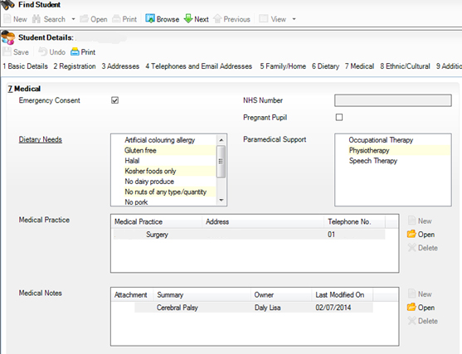

Visual difficulties
Key Traits:
- Difficulties seeing items at distance
- Close vision may be compromised
- ‘Blind’ spots in field of vision.
- Disruption processing visual information (in the eye or brain)
- Difficulties seeing colours, shades and tones
- Text appears to move around the page or over the top of other text.

Teaching strategies:
- Avoid copying work off the board, if needing to use the board make sure the pupil sits near to the front of the class or can see the teacher’s computer. Use verbal description of the work being done, for example, “Write the title, ‘Categories of Vegetables’ in the middle at the top of your page, as it is on the board.”
- Permit alternative note-taking methods including providing large-print handouts and allowing photography for instant enlargement
- When demonstrating practical elements of the subject, bring the pupils around the table where the demonstration is taking place, make sure the pupil with visual difficulties is close. If possible, allow pupils to pass around items being shown
- Enlarge pupil’s work sheets and use enlarged text books
- Pupil may have a magnifying glass/ ruler for use with smaller textbooks.
- Label coloured pencils and other coloured items in the class. There are varying degrees of colour blindness, but the ability to distinguish between shades is often compromised
- Ensure work is in a clear, bold print
- Ensure diagrams / graphs etc. are clear
- Coloured overlays may be useful to reduce glare
- Consider providing .pdf files that can be read & enlarged on a computer
- Consider GCSE Access Arrangements, use of word processor / assistive technologies.

Hearing Difficulties
Key Traits:
- Missing some or all of instructions
- Particular difficulty when teacher’s mouth obscured (many use lip-reading to reinforce what they hear)
- Especially difficult in areas with high background noise

While some students may have permanent hearing loss, many other students may suffer temporary losses from colds and ear infections. Since even temporary losses can have an effect on language development and access to curriculum, the strategies mentioned here are worth using by every teacher.

Classroom Adaptations
When possible, turn off equipment that creates background noises, such as fans and projectors, when not in use. If your classroom has noisy heating or cooling systems, consider requesting a room change. Eliminating extra noise helps students with hearing impairments focus on the lesson. Remember that hearing aids amplify every sound, including tapping pencils and air conditioners. Carpets, curtains and tennis balls on chair bottoms can also eliminate a great deal of extraneous noise.

Communication Considerations
Effective communication is vital with a hearing-impaired student to ensure student success. Since many hard-of-hearing students rely on lip-reading, at least partially, it is important to keep a few points in mind when you are teaching:
- Look directly at and face the student when communicating. Do NOT cover your mouth.
- Say the student’s name or signal their attention in some way before speaking.
- Assign the student a desk near where you plan to deliver most of your lessons.
- Speak naturally and clearly. Speaking louder may not help.
- Some students will have use induction-loop system. Wear this around your neck and remember to switch it OFF when addressing/helping other students!

Further Information
This is a working document. Please check the live online copy of this leaflet regularly for updates and let the team know if you have suggestions for improvement or are able to offer feedback.
Live copy stored in Staffroom Documents folder on Portal365.

Reading List

A range of titles are available for staff loan from the SEND / NAS professional library in the Staff Room.

References

Ofsted guidelines for teaching SEND http://lpec.org.uk/wp-content/uploads/2014/01/The-Ofsted-Framework-and-SEND-Updated-Jan14.pdf
Children and Families Act of 2014 http://www.legislation.gov.uk/ukpga/2014/6/contents/enacted/data.htm

