
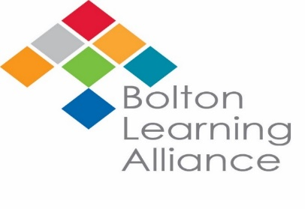

Bolton Learning Partnership
Supporting School Improvement Hub
Art & Design Development Plan
2019-20

‘We cannot accomplish all that we need to do without working together’
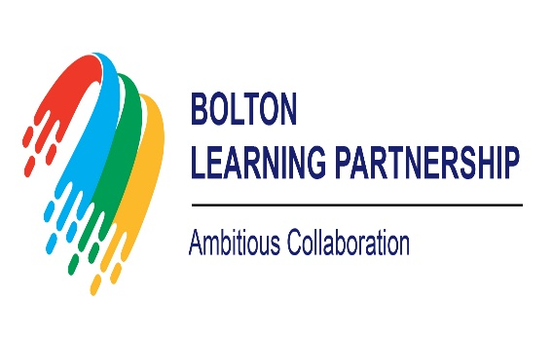

The Development Plan will have three overarching focus areas:
- Leadership – to develop and create leaders; to deepen the skills & knowledge of leaders; to share best leadership practice within and across schools; to create leadership capacity in schools and for school improvement.
- Teaching and Learning – to develop pedagogy in schools; to share best teaching & learning practice within and across schools; to support the raising of attainment and progress of all students at all levels and from all backgrounds.
- Intervention – to develop school to school support to meet the immediate needs of individual schools; to share best intervention practice within and across schools; to support schools to meet short term targets for their students and their school.

The Development Plan will be developed coherently alongside the plans of the ‘Teaching School Alliances’ to avoid competition, duplication and to deploy skills and resources effectively to meet the needs of all students and the schools.

The Structure of the Plan
Aim What are we aiming to achieve overall
Objective What are we specifically focusing on to achieve our aim
Action What are we going to do to achieve our objective
Lead Who is strategically leading these actions
Timescales When are these actions planned to be completed
Evidence Where will we find the evidence of progress towards the objective
Impact What does the evidence tell us about progress towards the aim

Leadership
Aim: to develop and create leaders; to deepen the skills & knowledge of leaders; to share best leadership practice within and across schools; to create leadership capacity in schools and for school improvement

Objective | Action | Lead | Timescales | Evidence | Impact
Empower others in your team to build capacity within your department. | Take specific expertise from key members of Art departments to broaden your scope for the GCSE specification. There could be opportunity for departments to work together where there is some knowledge deficit within a team. | Initially JF, then subject leads | By end of 2019/20 | CPD sessions to be available by request on a ‘teacher to teacher’ basis where there is need for some training on a specific area of expertise within GCSE (practical workshops?) | Some teachers will be empowered to lead a CPD session to teachers from other schools.  Some teachers will have evidence that they have been to a session delivered by another teacher and will be in a position to share this learning with the own department.
To develop greater participation in Art Hubs | Meet key Art Leads across the cluster for a 1 to 1 meeting to help develop key support structures and help share best practice | JF | By third meeting | Meetings | Secure greater progress for key students in Art through the sharing of best practice
Teaching and Learning
Aim: to develop pedagogy in schools; to share best teaching & learning practice within and across schools; to support the raising of attainment and progress of all students at all levels and from all backgrounds.

Objective | Action | Lead | Timescales | Evidence | Impact
Develop our own standardizing sessions to embed the new grade boundaries | Use November meeting to identify the key features of Grade 5/6 portfolio and EST work | JF in first instance | Initial meeting | Meeting minutes  Evidence of best practice shared | Increased awareness Successful examples to be be implemented across the cluster to help secure progress for higher ability learners to achieve the highest grades
Share good practice in implementing ‘feedback’ at GCSE level, in line with JCQ guidelines for conducting NEAs | Bring along examples of feedback resources | Subject leaders | Initial meeting | Meeting minutes  Evidence of best practice shared | Successful examples to be implemented across the hub to help minimise workloads and meet guidelines
Intervention
Aim: to develop school to school support to meet the immediate needs of individual schools; to share best intervention practice within and across schools; to support schools to meet short term targets for their students and their school.

Objective | Action | Lead | Timescales | Evidence | Impact
Promote the way in which the Art HUB could offer support based on individual department strengths from the BLA. | Departments will be asked to bring one resource or part developed idea to the meeting so that we can start to build a collection of collaborative resources and contacts who can offer advice on the GCSE specification. | JF | Second meeting. | Bank of resources  Minutes | During meeting, the HUB members will say what help they have asked for and what resources they have used. This could lead to joint planning of resources that need to be developed.
Engaging Boys in Art & Design | Invite NSEAD in to deliver aspects of ‘where have all the boys gone?’ course? Will need funding – Jf to investigate costs. | JF | Third term | Minutes  Best practice shared | Eventual increase in Boys opting for Art & Design

Coming together is beginning; Keeping together is progress; Working together is success. Henry Ford

