Using AI in Geography
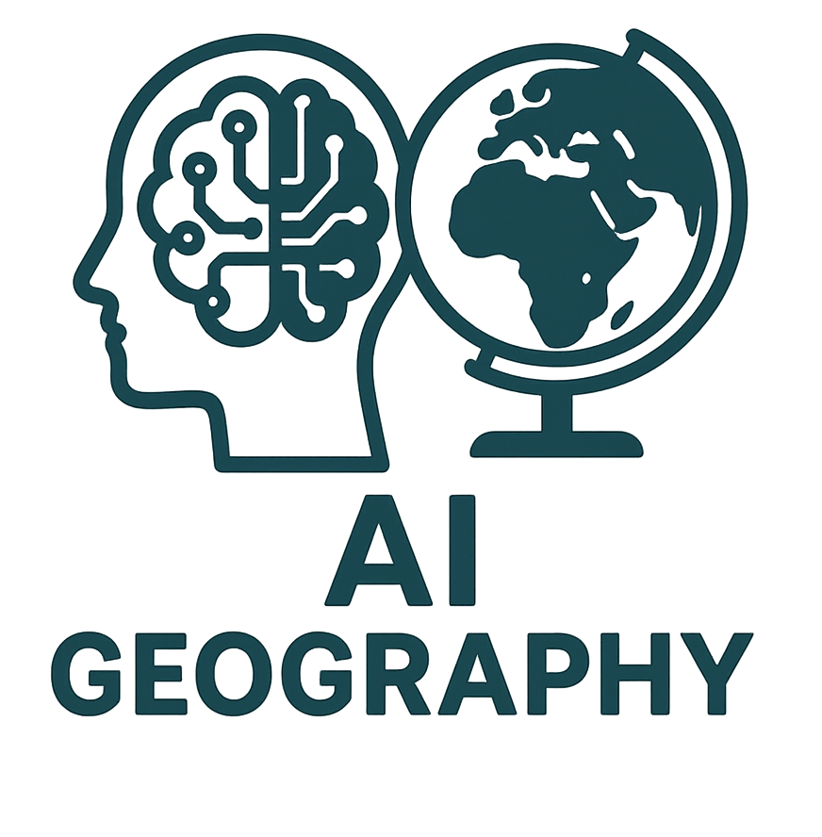
AI has the potential to significantly enhance geography teaching in UK secondary schools by offering personalised learning experiences, providing real-time data analysis, and fostering a more interactive and immersive environment. Several research studies and case studies highlight these benefits, demonstrating how AI can be effectively integrated into the geography curriculum. Below are some key ways AI can improve geography teaching, supported by specific examples and research:
1. Personalised Learning through Adaptive Learning Platforms
AI-powered platforms can offer personalised learning experiences by adapting to the specific needs of individual students. These platforms can adjust the content, difficulty, and type of exercises based on student performance, providing a tailored approach to geography education.
- Case Study: Century Tech in the UK
Century Tech, a UK-based AI platform, is used in secondary schools to deliver personalised learning. It uses AI algorithms to assess each student's learning patterns, identifying areas where they need more support. This adaptive learning is especially useful for geography, where students can learn at their own pace, and complex topics like climate change, urbanisation, and ecosystems can be broken down into more manageable segments based on individual needs. The platform helps teachers monitor student progress and address gaps in knowledge more effectively.
- Research by UCL Knowledge Lab
A 2020 study from UCL’s Knowledge Lab examined the impact of AI in education, including its role in geography. The study found that AI tools could improve engagement by providing personalised feedback and adaptive learning pathways, particularly in subjects like geography where spatial understanding varies among students. The research highlighted the potential for AI to make learning more student-centred and efficient.
2. Enhancing Spatial Skills with AI-Driven Visualisation Tools
Geography heavily relies on spatial thinking and the ability to interpret complex data like maps, climate patterns, and population distributions. AI-powered tools can enhance students' spatial skills by providing dynamic visualisations, allowing students to interact with 3D maps, real-time satellite imagery, and geographic information systems (GIS).
- Google Earth Engine in Geography Education
Google Earth Engine (GEE) is an AI-powered platform that allows students to analyse and visualise large-scale environmental data. Schools in the UK have integrated GEE into geography lessons, enabling students to explore real-time environmental changes like deforestation, urban sprawl, and climate variations. A study by the Royal Geographical Society (RGS) noted that using GIS and AI-enhanced tools helped improve students’ understanding of complex geographic processes by making them more tangible and visually engaging.
- University of Leeds - AI in Climate Change Education
A project by the University of Leeds tested AI-driven climate modelling tools in UK secondary schools to help students understand the impact of climate change. By using AI to simulate future climate scenarios based on current data, students gained a clearer understanding of geography topics related to climate systems and sustainability.
3. Automated Assessment and Feedback
AI can assist teachers in assessing students' work more efficiently by automating marking and providing instant feedback. This reduces the burden on teachers and allows them to focus more on pedagogy and individualised support. Automated assessment tools can be particularly effective in evaluating geography essays, data interpretation exercises, and map analysis.
- Research by Nesta (2020)
In a report by Nesta, AI’s potential in education was explored, with a focus on automated assessment tools. In geography, AI can evaluate complex student responses to open-ended questions, such as essays on human geography or case studies on natural disasters. This speeds up the feedback process and provides detailed insights into areas where students may struggle, such as critical thinking or spatial analysis.
- Case Study: EdTech Demonstrator Programme (UK Department for Education)
As part of the UK government's EdTech Demonstrator Programme, schools are using AI to support formative assessments in subjects like geography. These tools can mark short-answer questions related to geographic knowledge (e.g., physical features, map reading, population data) and offer students immediate feedback on their performance, thus improving learning outcomes.
4. Interactive AI-Enhanced Learning Environments
AI-powered tools can create immersive, interactive learning environments, enhancing students' engagement with geography. Virtual reality (VR) and augmented reality (AR), when combined with AI, allow students to explore virtual landscapes, historical sites, and global phenomena, deepening their understanding of geographic concepts.
- Case Study: VR in Geography Education (The Geographical Association)
The Geographical Association has explored using VR in geography lessons, particularly in topics such as fieldwork and landscape studies. AI can enhance these VR experiences by dynamically generating environments based on real-world data. For example, students can virtually explore a volcano or rainforest, examining geographic features and processes in a highly interactive manner.
- Research by Swansea University on Immersive Learning
Swansea University researchers conducted a study on immersive learning environments in geography education, highlighting how AI-enhanced VR tools can improve student engagement and understanding. The study found that students who used VR combined with AI-powered simulations were more engaged and performed better in understanding geographic systems, such as plate tectonics and ecosystems, compared to traditional learning methods.
5. Supporting Teachers with AI-Driven Insights
AI can also support geography teachers by providing data-driven insights into student performance and engagement. AI tools can analyse student data to identify trends and make predictions about future performance, enabling teachers to intervene early and provide targeted support.
- Research by OECD (AI and the Future of Teaching)
A 2019 OECD report discussed the role of AI in supporting teachers, particularly in data analysis. In geography, AI tools can track how students engage with content, which topics they struggle with, and how their spatial reasoning skills develop over time. Teachers can then use this data to adjust their teaching strategies and provide additional support where needed.
6. Fieldwork Enhancement Using AI Tools
Fieldwork is a key component of geography education, but organising and analysing data collected during field trips can be time-consuming. AI can streamline this process by analysing geographical data, such as land use patterns, climate conditions, and population demographics, collected during fieldwork.
- Case Study: AI in Fieldwork Data Analysis (Royal Holloway, University of London)
A project led by Royal Holloway, University of London, used AI tools to help students analyse data collected during geography field trips. AI systems were employed to process large datasets quickly, offering insights into patterns in soil composition, land use, and environmental changes. This allowed students to focus more on interpretation and application rather than manual data processing, significantly improving learning outcomes.
Conclusion
AI offers numerous opportunities to enhance geography teaching in UK secondary schools by personalising learning, improving spatial understanding, automating assessments, creating immersive learning environments, supporting teachers, and enhancing fieldwork. Research from institutions like UCL, Swansea University, and case studies from platforms like Century Tech and Google Earth Engine illustrate the transformative potential of AI in geography education. These tools not only make geography more engaging and accessible but also help develop critical thinking and analytical skills, preparing students for a rapidly changing world.

