Other Exam Boards Examiner Feedback

OCR general examiner’s feedback
Geographical Themes- Paper 1
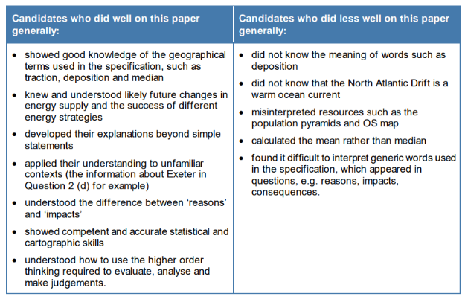
Geographical Themes- Paper 2

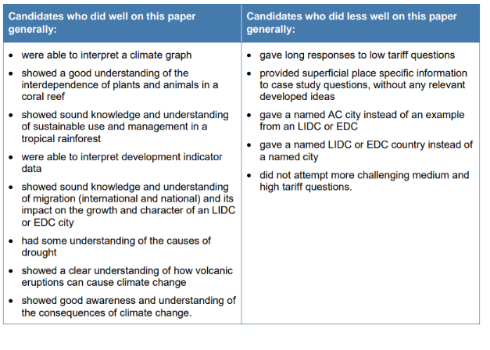
Geographical Themes- Paper 3
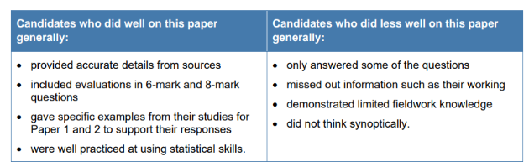
Edexcel
Paper 1
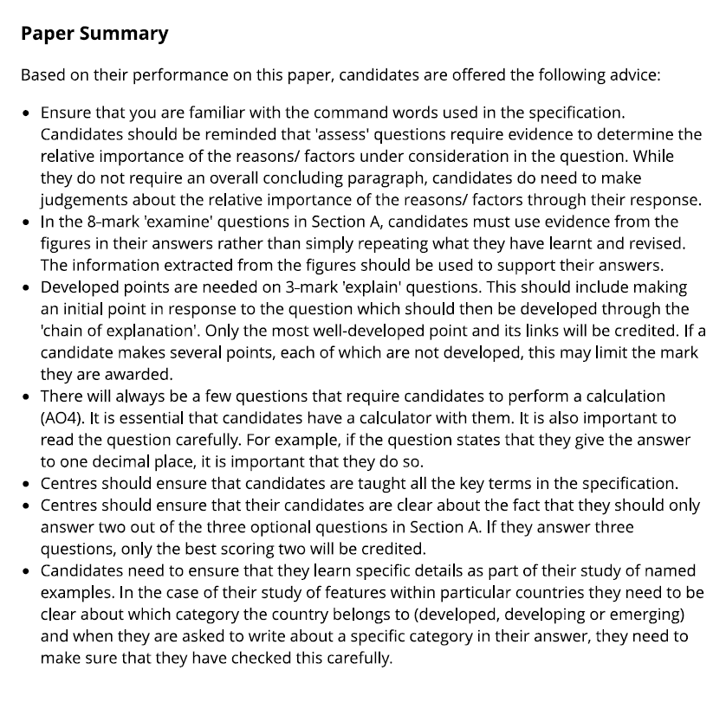

Paper 2
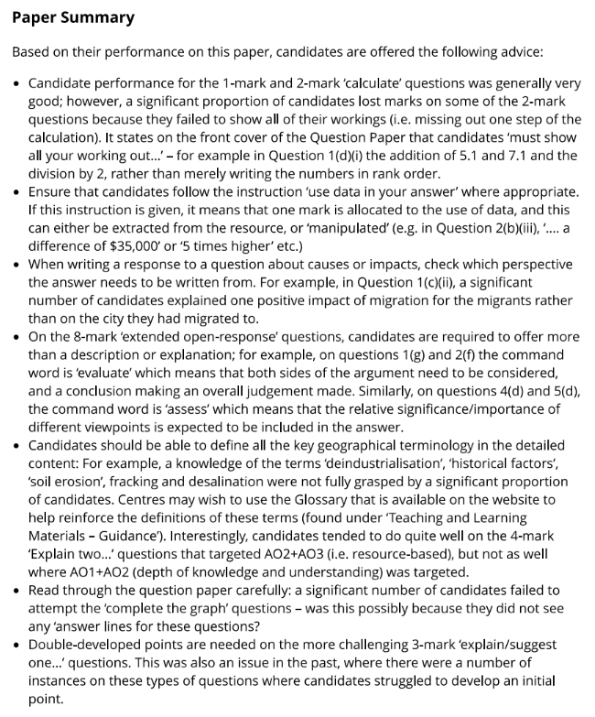

Paper 3
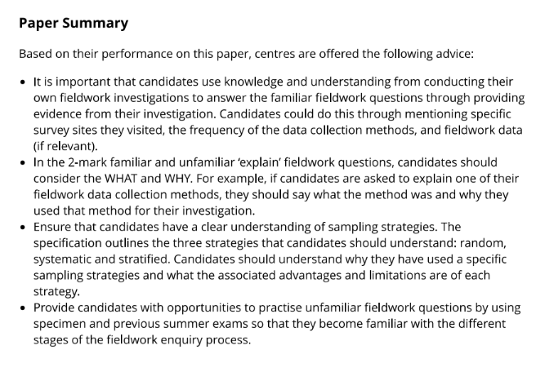
WJEC summary
