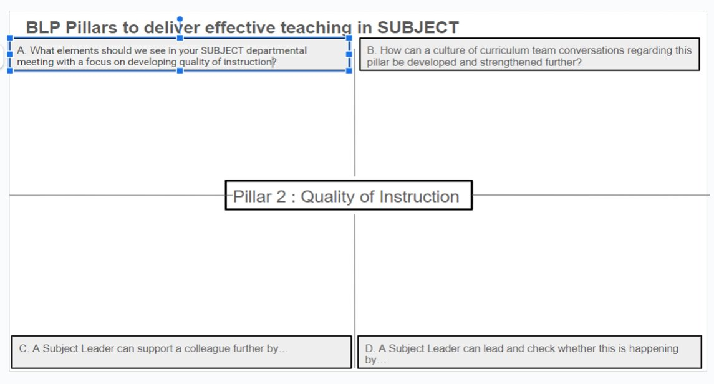
-Showcasing key information
-Training PowerPoint to be shared with all staff in departments across Bolton
-Create further links with the Bolton Learning Partnership
-Supports ECTSs / Non-subject specialists
-Review Schemes of learning
-Staff understand the connections between schemes of learning and can demonstrate these effectively
-Subject specific training
-QA/ Drop ins
-Other members of the team leading training session if they are the expert in the field
- Work Scrutiny
Pupil voice
-Drop ins
-Departmental meetings
-Subject videos highlighting how great quality of instruction looks – Key staff being filmed
-Training
-Expert HOD – Talk through the lessons
-Lesson observations of the experts

-Collaborative planning
-Different teachers to deliver training based on their specialism within History
-Pin point core knowledge – Time to think about what is the core knowledge that all of the students need to know
- Discussions on curriculum and curriculum delivery become the norm.

