-Plate Tectonic Theory
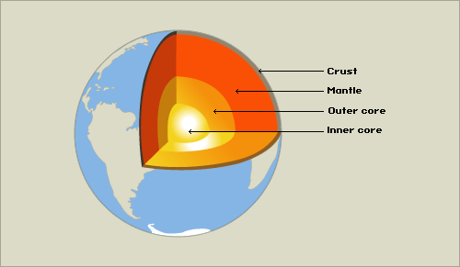
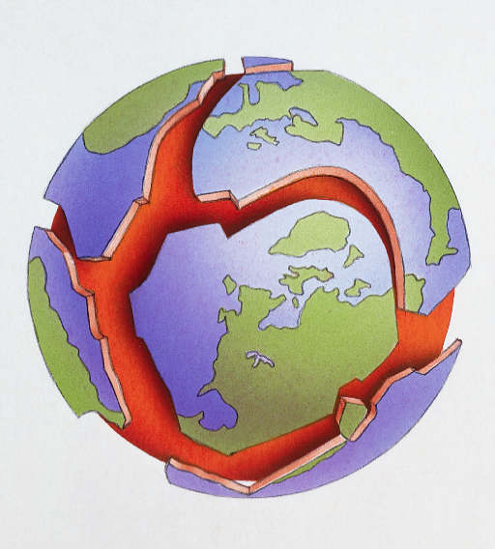
The earth has 4 layers, the mantle is hot, liquid rock and the crust floats on top. The crust is broken into plates and moves due to convection currents in the mantle, this causes continental drift as the continents on the crust move.

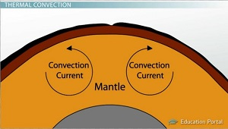

Structure of the earth Crust broken into plates Convection currents moving plates

-Plate Tectonic Theory
The earth has 4 layers, the mantle is hot, liquid rock and the crust floats on top. The crust is broken into plates and moves due to convection currents in the mantle, this causes continental drift as the continents on the crust move.

Structure of the earth Crust broken into plates Convection currents moving plates

