CANON SLADE SCHOOL KS3 YEAR 7 PE KNOWLEDGE ORGANISER – Components of Fitness
Motor Competency (Tests)

Strength - Hand grip dynamometer.

Strength – One rep max test

Cardiovascular endurance - Multi-stage fitness test

Sporting Examples

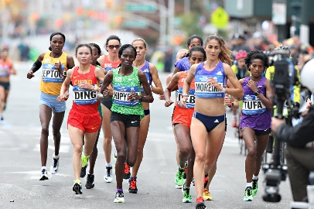

Marathon Runner= Cardiovascular Endurance



Winger changing direction = Agility
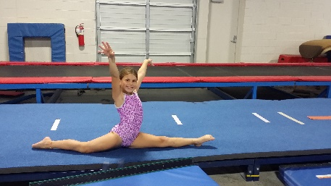

Gynmast performing= Flexibility

Cardiovascular endurance – Twelve minute Cooper run or swim

Flexibility - Sit and reach test

Definitions

Muscular Endurance:- the ability of the muscle or group of muscles in the body to repeatedly contract or keep going without rest or fatiguing.

Co ordination :- the ability to move different limbs at different times or to do more than one task at a time effectively.

Flexibility:- the amount or range of movement that you can have around a joint.

Power :- often referred to as fast strength. It is a combination of speed and strength.

Muscular strength:- the maximum force a muscle/group of muscles can apply against resistance.

Speed:- the ability of the body to move quickly – this can be whole body or just parts of the body.

Agility:- how quickly you can change direction under control and maintaining speed, balance and power.

Balance:- the ability to keep your body mass or centre of mass over a base of support.

COF Key Words
Agility
Balance
Co-ordination
Power
Reaction Time
Speed
Muscular Strength
Muscular Endurance
Cardiovascular Fitness
Flexibility

Year 7 PE Key Words

Pulse Raiser
Mobilise
Dynamic
Interception
Consistency
Accuracy
Cooperate
Defence
Attack
Pressure
Cardiovascular endurance Speed
Control
Agility



Speed - 30 metre sprint test

Muscular endurance - 60 second sit-up bleep test

Body composition – skin fold callipers

Coordination – Alternate hand wall toss test

Reaction time - Ruler drop test

Balance - Standing stork test

Power - Vertical jump test

Reaction Time:- the time between the onset of the stimulus and the initiation of the response.
Cardio Vascular Fitness - the ability to continuously exercise without tiring.
Health Related Fitness
Skill Related Fitness
Body Composition

