CANON SLADE SCHOOL KS3 YEAR 7 PE KNOWLEDGE ORGANISER – Stages to a Warm Up.
Motor Competency
Warm Up
Pulse Raiser exercises - to slowly raise heart rate and gradually increase body temperature e.g. jogging

Examples

Pulse Raiser: Jogging
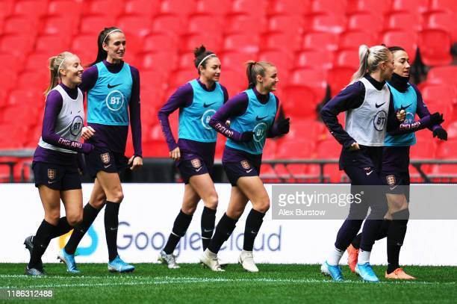

Dynamic Stretches: High Knees
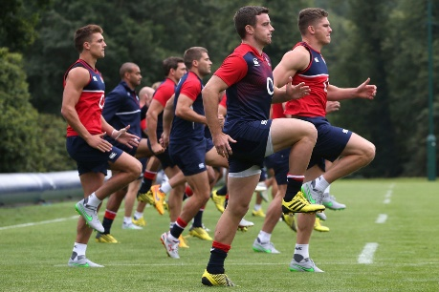

Games Based Activity/Skill Rehearsal: Passing the ball between two.
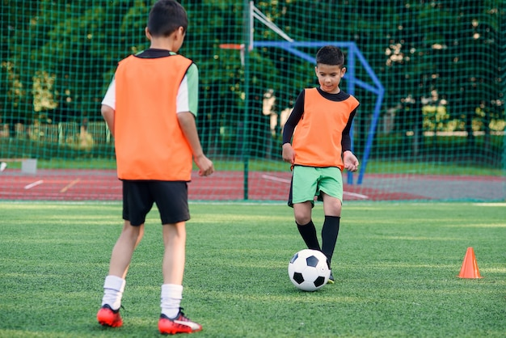

Mobility: exercises that take joints through their full range of movement e.g. high knees / arm swings

Stretching can include static or dynamic type stretches e.g. lunges, hamstring stretch

Stretches

Dynamic Stretches

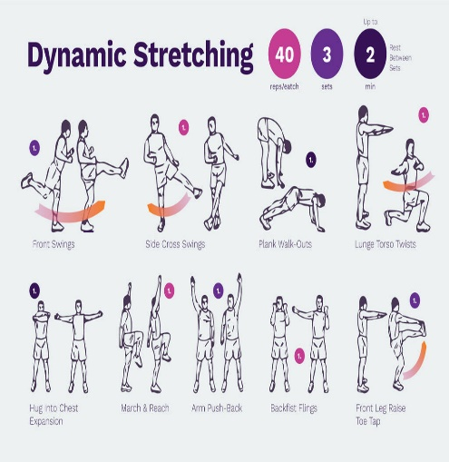

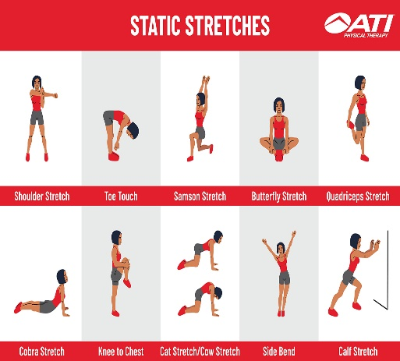

Key Words
Warm Up
Cool Down
Pulse
Pulse Raiser
Mobilisation
Dynamic Stretches
Static Stretches
Games Based Activity
Skill Rehearsal

Year 7 PE Key Words

Pulse Raiser
Mobilise
Dynamic
Interception
Consistency
Accuracy
Cooperate
Defence
Attack
Pressure
Cardiovascular endurance Speed
Control
Agility


Static Stretches
Mental
Physical
Social

Stretching: can include static or dynamic type stretches e.g. lunges, hamstring stretch

Dynamic Movements that show a change in speed and direction e.g. shuttle runs

Games Based Activity/Skill Rehearsal: practising the common movement patterns and skills that will be used in the activity e.g. dribbling drills for football, shooting in basketball.

