CANON SLADE SCHOOL KS3 YEAR 7 PE KNOWLEDGE ORGANISER – How does the type of exercise help towards fitness?
Motor Competency (Types of training)

Sporting Examples

Plyometric Training: Box Jumps

Interval Training: High Intensity

Fartlek Training: Speed Play on different terrains.

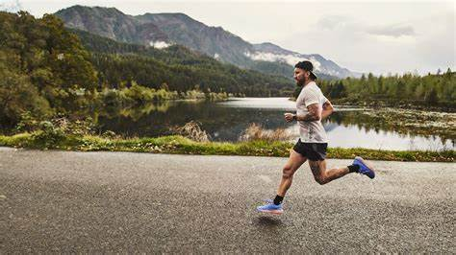

Plyometric Training

Continuous Training

Interval Training

Fartlek Training

Weight Training

Flexibility Training

Circuit Training

Yoga

Definitions

Plyometric Training:
Plyometric training develops power
High intensity exercise involving explosive movements.

Continuous Training:
Continuous training develops cardiovascular fitness. A minimum of 20 minutes sub-maximal work.
Interval Training:
Interval training develops strength, speed and muscular endurance
Periods of intense work interspersed with timed rest
Fartlek Training: Fartlek (speed play) training develops a range of components and is used by games players
A continuous form of training. Changes in speed, incline and terrain are used to provide changes in exercise intensity.
Weight Training:
Intensity is measured in a percentage of the most weight a person can lift one time

Flexibility Training

Time is measured by the length of hold and the recovery period between holds

Circuit Training:
Stations are set out that train one or more components of fitness.
The performer moves from one station to the next with exercise periods and rest periods.

Key Words
Plyometric
Cardiovascular
Endurance
Interval
Fartlek
Weight
Flexibility
Circuit

Year 7 PE Key Words

Pulse Raiser
Mobilise
Dynamic
Interception
Consistency
Accuracy
Cooperate
Defence
Attack
Pressure
Cardiovascular endurance Speed
Control
Agility

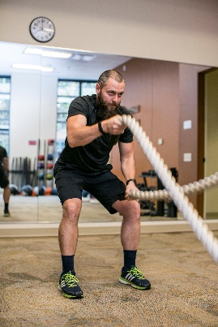


Exercise
Fatigue
Reaction
Fitness
Aerobic
Anaerobic
Intensity

