CANON SLADE SCHOOL KS3 YEAR 7 PE KNOWLEDGE ORGANISER – How does the body react to different types of exercise?
Motor Competency (Types of exercises)

Examples

Sweating: Temperature Regulation
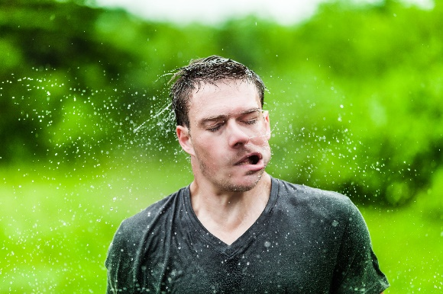

Fatigue: Tiredness/Exhaustion
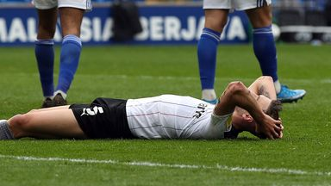

Mental Stimulation: Happier

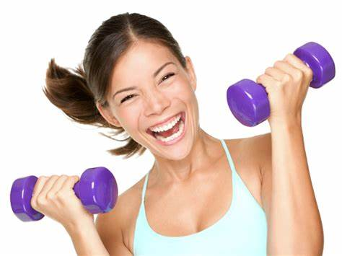

Plyometric Training

Continuous Training

Interval Training

Fartlek Training

Weight Training

Flexibility Training

Circuit Training

Yoga

Definitions

What happens as you start exercising?

- You breathe heavier and faster.

- Your heart beats faster.

- Your muscles start to fatigue.

- You sweat to control body temperature.

- Exercise makes the nervous system work into action, which causes the heart to beat faster and increasing the blood supply to the brain and muscles.

- Your body produces lactic acid, which stops muscles from working. The longer you exercise, the more lactic acid you have in your muscles, which can eventually lead to cramping and muscle fatigue.

Key Words

Heart
Heart Rate
Cardiovascular
Respiratory
Nervous System
Mental Stimulation
Fatigue
Exothermic reaction
Exercise
Plyometric
Continuous
Interval
Fartlek
F

Year 7 PE Key Words

Pulse Raiser
Mobilise
Dynamic
Interception
Consistency
Accuracy
Cooperate
Defence
Attack
Pressure
Cardiovascular endurance Speed
Control
Agility



