Pearson Edexcel
GCSE History

Spring term 2021
Online network events

Paper 3, Question 3
AO3 and AO4 questions

Delegate Booklet

This pack is for delegates attending the GCSE History network event for Paper 3, Question 3 questions. This pack contains the exemplar material that you will need during the meeting, as well as a space to type any notes or comments.

This GCSE History network will allow delegates to:
- Revisit the Paper 3 question 3 sources and interpretations question and how it is assessed
- Talk through some marked exemplar student answers
- Network and share teaching ideas and strategies
Are there any updates or new resources that Pearson are offering which you would like to check out after this meeting?

Paper 3, Question 3: a package
Notes on the format and structure of Paper 3, Question 3:

Question 3a: working with sources – the source utility question
Notes on the 8 mark source utility question:
Generic mark scheme for 8-mark source utility questions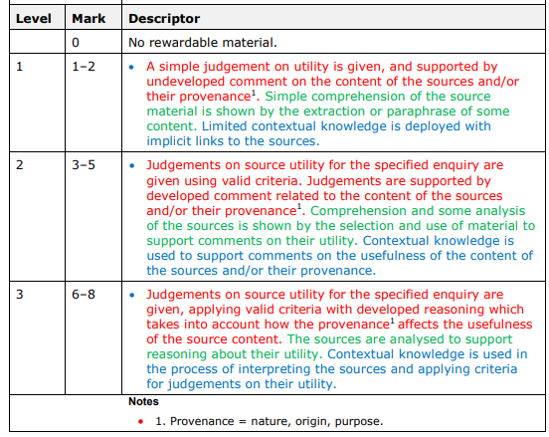

Paper 3, Question 3a – Question and Sources
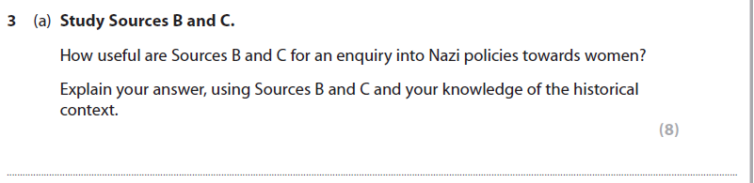
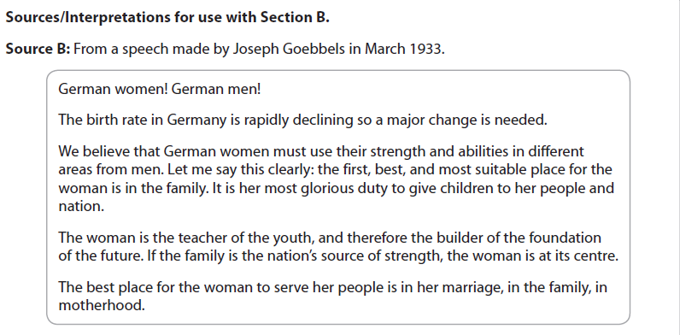

Indicative Content – mark scheme
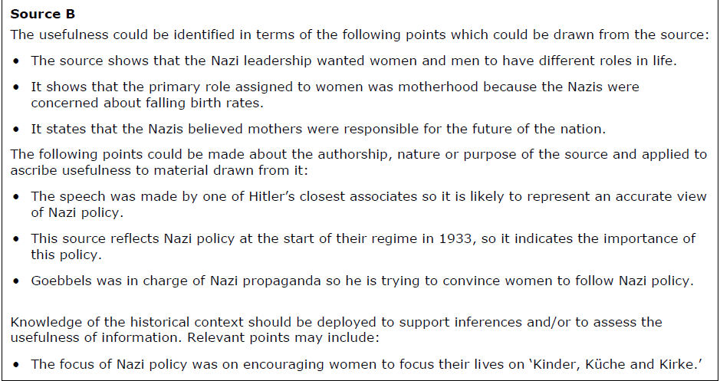
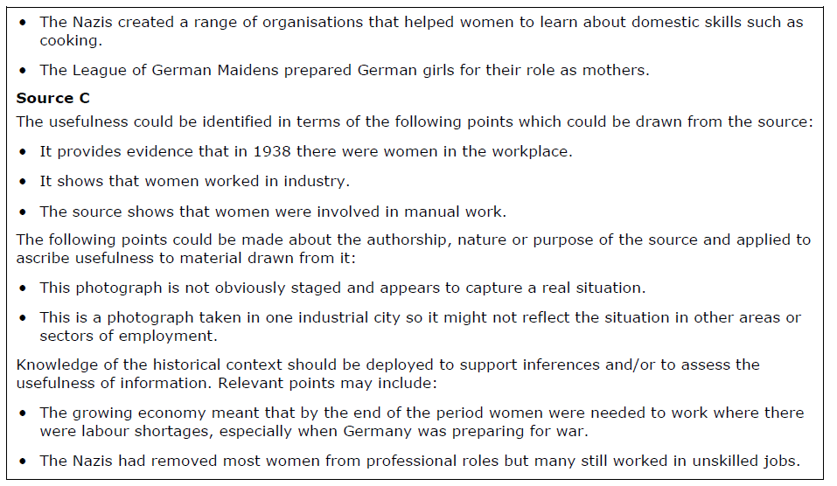

Response 1

Response 2
Notes on marking and examiner commentary:

Interpretations (AO4) as part of Paper 3, Question 3
Notes on Interpretations in the GCSE specification:

Paper 3, Question 3b – identifying difference
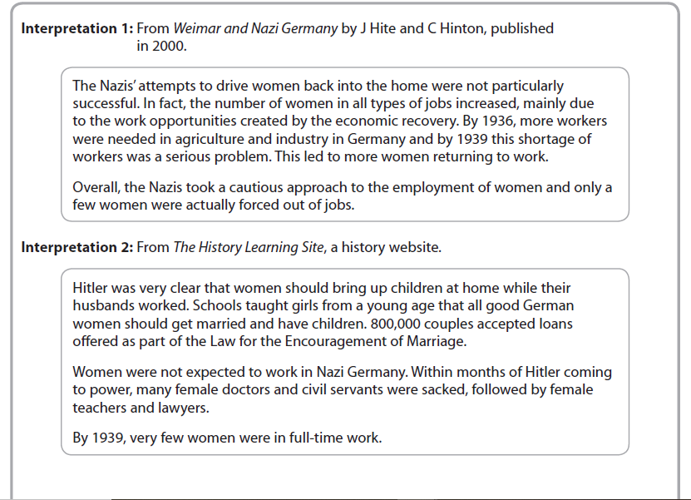
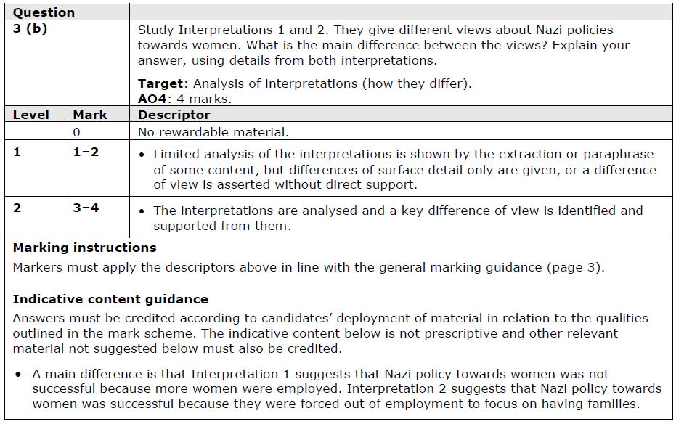
Response 3

Response 4

Paper 3, Question 3c – explaining difference
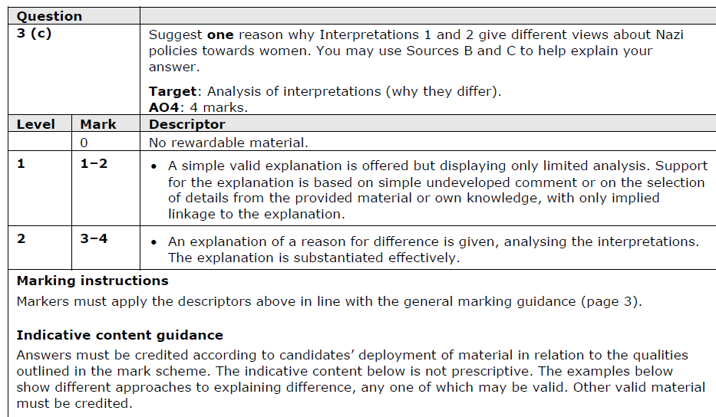
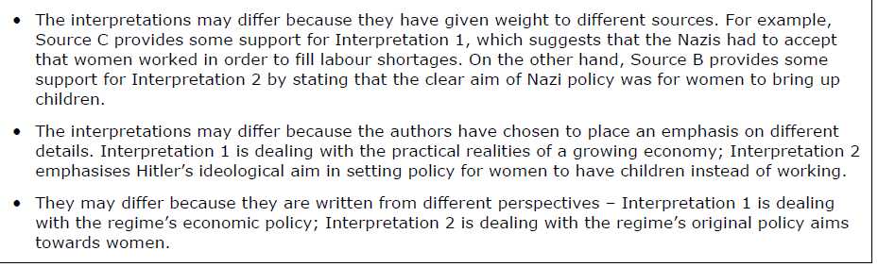

Response 5
Response 6
Notes on marking of Questions 3b and 3c:

Paper 3, Question 3d – evaluating an interpretation
Generic mark scheme
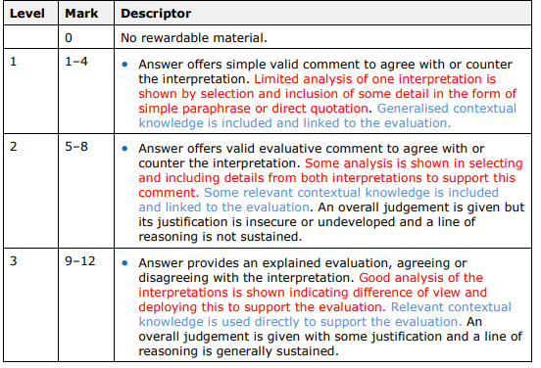
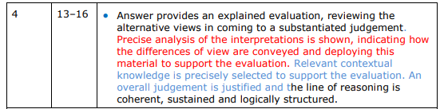
Notes on Question 3d mark scheme:

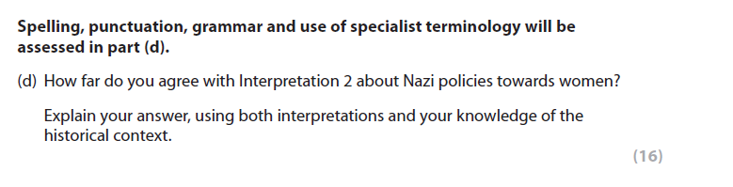
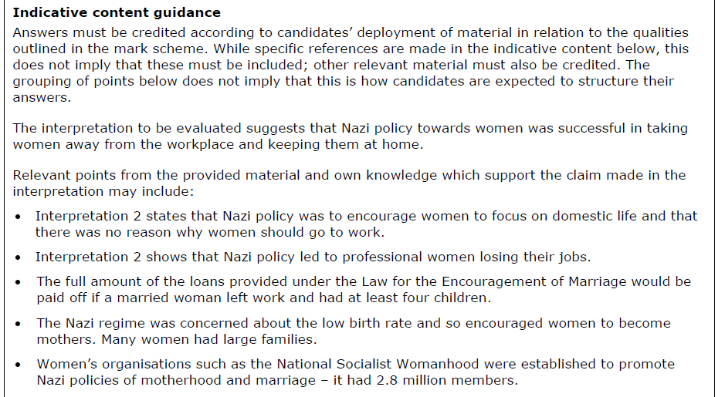
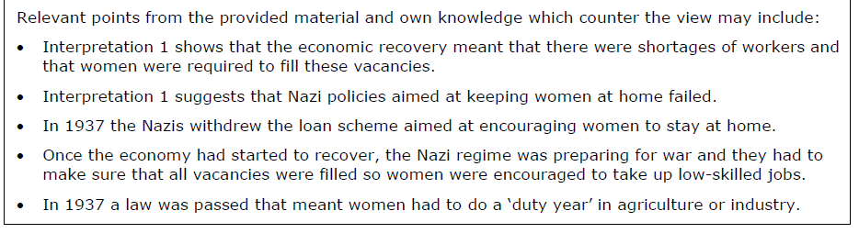

Response 7
Response 8
Notes on marking and examiner commentary of Question 3d:

Sharing good practice / Reflections and questions
Use this space to record any ideas, teaching strategies or other notes from the discussion:

