Multiagency Neglect Strategy
(2020-2023)
Bolton Safeguarding Children Partnership

‘No opportunity is missed and no opportunity is ignored to respond to child neglect’

1.0 Introduction

The experience of neglect during childhood can have significant, long-lasting and pervasive consequences, affecting all aspects of a child’s development and their lives into adulthood. It is the most common type of abuse experienced by children.

Neglect has been a priority for the Safeguarding Board and Partnership for the past three years. We know we still need to do more so that children have their needs met by their parents or carers, and support is provided where this is not the case. We want to ensure that we identify and prevent unmet needs from escalating so that all children in Bolton receive the childhood they have a right to. We want all families and children within them to thrive.

It is important to note that this Neglect Strategy has been written at the time of the Covid19 pandemic which is both a health and social crisis particularly for some of our most vulnerable children and families. Due to the impact of COVID19 many children will face new challenges over the months and years to come due to missed education during lockdown, the impact of isolation, the impact from increased conflict in the home, financial hardship, food poverty, poor emotional health and wellbeing and the impact of the ‘pressure cooker’ effect on families in the home environment. Local leaders and the Bolton workforce will need to support these children and families whilst themselves adjusting to new ways of working. It also needs to be acknowledged that some of the success measures laid out in this strategy may be more challenging to achieve due to the wider impacts of COVID19 however our aim will be to monitor themes and trends in order to respond effectively as a partnership.

This document sets out Bolton’s approach to preventing and reducing neglect across the town with the aim to improve outcomes for children, young people and families. We ask all agencies and professionals along with the wider voluntary sector and community to read this Neglect Strategy, sign up to it and consider how you can make a purposeful contribution to its implementation.

2.0 Values and Behaviours

In our work with children, families, wider communities and across our services:-

- We will listen to what children and their families tell us, treating them with respect and kindness
- We will seek to understand children’s lived experiences at all times
- We will work restoratively with families and each other to build up trust and to ensure a culture of high support and high challenge
- We will share information in a timely manner to ensure that we identify and respond to neglect early
- All partners will have knowledge of the impact of neglect on children and will understand their role in identifying and responding to neglect
- We will use early help effectively to support our children and families at the earliest opportunity
- To recognise and understand the impact of adverse childhood experiences (ACES) as described in
Section 5

3.0 Definition of Neglect

All grown-ups everywhere have a duty to uphold Article 27 of the UN Convention on the Rights of the Child (1989): the right of every child to a standard of living adequate for the child's physical, mental, spiritual, moral and social development.

The statutory definition of neglect is laid out in Working Together to Safeguard Children (2018):

The persistent failure to meet a child’s basic physical and/or psychological needs, likely to result in the serious impairment of the child’s health or development. Neglect may occur during pregnancy as a result of maternal substance abuse. Once a child is born, neglect may involve a parent or carer failing to:
a. provide adequate food, clothing and shelter (including exclusion from home or abandonment)
b. protect a child from physical and emotional harm or danger
c. ensure adequate supervision (including the use of inadequate caregivers)
d. ensure access to appropriate medical care or treatment
It may also include neglect of or unresponsiveness to a child’s basic emotional needs.

Whilst the statutory definition refers to ‘persistent failure to meet needs’, neglect can be episodic or cumulative. This is important as we need to work to address neglect before it meets the threshold for statutory intervention. Neglect can also be intentional or unintentional.

The main types of neglect are:-

Physical neglect
A parent/carer does not provide appropriate clothing, food, cleanliness and/or living conditions.

Educational neglect
A parent/carer fails to provide a stimulating environment or show an interest in the child’s education at school/education provision. They may fail to respond to any special needs and fail to comply with state requirements about school attendance.

Emotional neglect
A parent/carer is unresponsive to a child’s basic emotional needs. They may fail to interact or provide affection, undermining a child’s self-esteem and sense of identity. (Most experts distinguish between emotional neglect and emotional abuse by intention; emotional abuse is intentionally inflicted, emotional neglect is an omission of care.)

Medical neglect
A parent/carer minimises or denies a child’s illness or health needs and/or fails to seek appropriate medical attention or administer medication and treatment.

Nutritional neglect
A child does not receive adequate calories or nutritional intake for normal growth (also sometimes called ‘failure to thrive’). At its most extreme, nutritional neglect can take the form of malnutrition or obesity.

Lack of supervision and guidance
A parent/carer fails to provide an adequate level of supervision and guidance to ensure a child’s safety and protection from harm. For example, a child may be left alone, abandoned, left with inappropriate carers, or they may not be provided with appropriate boundaries about behaviours (for example, under-age sex or alcohol use).

4.0 Impact of Neglect at Different Ages

Neglect can occur from pre – birth through to 18 years and has long lasting impact (See also appendix 1).
Pre-birth
The impact of neglect can start before birth. Pre-natal neglect may be associated with (but not exclusively): drug use or alcohol consumption during pregnancy, failure to prepare for a new baby, failure to attend prenatal appointments and/or follow medical advice. A baby can also suffer from the effects of domestic abuse either directly or indirectly.

Infancy (birth to two years)
A baby’s growth and development is linked to their interaction with the world and their caregivers. Emotional and cognitive development e.g. games like ‘peek-a-boo’ where actions are repeated for social and emotional reinforcement from the reactions of caregivers, and neural connections are ‘fixed’ through stimulation. Disinterest or indifference to such actions and/ or failing to offer stimulation will limit the child’s development and growth. A secure attachment to a primary caregiver is the foundation that allows children to learn to trust others and explore the world around them. Studies have shown that children with disrupted attachment who have experienced neglect have problems coping and managing emotions, have more hopelessness, and have a poor self-concept. The ongoing nature of chronic neglect significantly impacts the brain in infancy and early childhood.

Pre-school (two to four years)
Most children of this age are mobile and curious, but lack understanding of danger; they need close supervision for their physical protection, which neglected children may not experience. Children may not be appropriately toilet trained if they are in neglectful families, as this process requires patient and persistent interaction and encouragement. Children’s language development may be delayed if their caregivers are not interacting with them sufficiently, and physical care may be inadequate.

Primary age (five to eleven)
For some neglected children, school can be a place of sanctuary. However, if their cognitive development has been delayed and they are behind their peers at school, it can also be a source of frustration and distress. Signs of neglect, e.g. dirty or ill-fitting clothing, will be apparent to peers, teachers and to the children themselves, and may cause embarrassment and difficulties in their social interactions. Children without clear and consistent boundaries at home can struggle to follow school rules. Educational neglect can include failing to ensure that children attend school, and high levels of absence can further impair their academic achievement.

Adolescence (twelve to eighteen)
Neglect is likely to have an impact on the young person’s ability to form and maintain friendships and pro-social relationships, though the young person may be more reluctant to disclose their situation if they fear becoming looked after or being split up from their siblings. Whilst adolescents can find sufficient food for themselves, they are likely to be drawn to the availability of convenience foods if they have never learned to prepare meals. Adolescent risk-taking behaviour may be associated with, attributed to or exacerbated by a lack of parental supervision, which can expose neglected young people to the risk of harm through, for example, alcohol and substance misuse, risky sexual behaviour or criminal activity. Resilience to neglectful situations does not increase with age, and can have significant consequences for emotional wellbeing.
Section taken from Taken from Horwath (2007) and the Lancashire Multiagency Neglect Strategy (2019)
5.0 Adverse Childhood Experiences/ Adverse Community Environments
The Serious Case Review (SCR) Triennial Review 2014 – 2017 (Brandon et al 2020) noted the extremely high prevalence of adverse parental and family circumstances within the cases where neglect was a feature. Poverty was also a significant and overriding issue.
Adverse childhood experiences (ACEs) are traumatic events occurring before the age 18 and these are highlighted in the infographic below along with adverse community environments. Evidence shows that when children are exposed to adverse and stressful experiences, it can have a long-lasting impact on their ability to think, interact with others and on their learning. The impact of ACEs however should not be seen as someone’s destiny. There is much that can be done to offer hope and build resilience in children, young people and adults who have experienced adversity in early life.
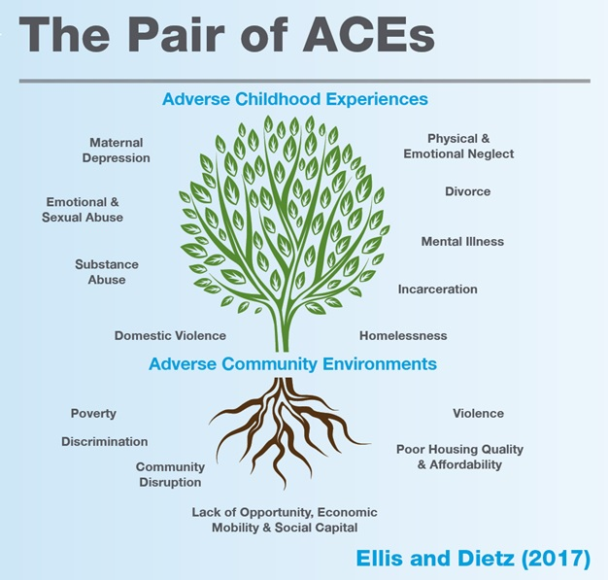

6.0 Young People’s View of Neglect
Further work needs to be undertaken in Bolton to help us understand neglect from a child’s perspective and this will be a key priority within the Neglect Strategy. This was what neglect felt like to children who participated in work for the Neglect Toolkit (University of Stirling, 2013).
You get the mickey taken out of you but you blame yourself, not your parents

Not enough love

Parents or step parents not having any interest in me

At school a boy shouted at me that I was from a bad family, so then I didn’t want people to know. Another girl told everyone and then I got the mickey taken out of me

At school, you can’t concentrate on the subject because things are bad in your life and then you feel it’s unfair because you get told off

It’s hard having no friends and other kids don’t realise how difficult that is

You cover up your feelings

Steven’s Story
Steven was 16 when he tragically took his own life in 2015.

Steven would have likely said that he was invisible, that he had no one looking out for him, no-one to talk to, no friends to hang out with, that he was scared at home by the violence and drug use and that he was frightened by his feelings which he did not understand. However, despite the involvement of services over a period of years, there was very little known by professionals about Steven; what he did all day when not at school; what were his sources of worry and anxiety, what thoughts he had about the future and why there was a need to be so ‘guarded’ when asked about family life. Professionals assumed a level of resilience in Steven, which was not tested, and they failed to recognise the full extent of the child’s vulnerability and take protective action.

Steven did not start school until he was 6 years old, his attendance was sporadic and in the last 2 years of his life he did not attend school at all. The serious case review into his death noted that the focus on school attendance left professionals addressing just one dimension of Steven’s life and important though that may have been, Steven’s psychological, emotional and mental health needs were of greater concern.

Steven was brought up in a chaotic family with 2 parents, grandparents and extended family. There were repeated episodes of violence in the home. On 3 occasions in his teenage years Steven attended A&E due to a hand injury which likely occurred at home. Dad spent time in prison for drugs related offences and both mum and dad were known to use drugs. Steven was repeatedly not taken for appointments including to CAMHS where he was referred due to concerns about his emotional presentation and his mum reporting an obsession with keeping clean. Steven spent time on a child protection plan in his younger years but similar concerns highlighted as he grew older were not addressed through statutory involvement. In the 10 months before his death he was not seen. The family were very hostile to professionals but Steven was seen as a quiet and polite boy.

To read more about Steven (child SB) please see
https://www.boltonsafeguardingchildren.org.uk/downloads/file/73/overview-report-child-sb

7.0 Parent’s Views on Neglect
Action on Neglect (2013) highlighted that professionals often have higher thresholds for neglect than the public. Parents within pre-school settings in Bolton have told us:
92% knew who to talk to if they were worried about a child

92% felt there needed to be more information
99% knew what neglect was

95% said we should talk to them and their children about neglect

8.0 Prevalence and evidence base
Nationally one in ten children will experience neglect (NSPCC 2013).
In the triennial review of SCR (Brandon et al 2020), neglect featured in 75% of the reports examined (208 out of 278) which is a rise of 15% from the previous triennial review. Neglect accounted for 68% of fatal cases and 83% of non-fatal serious harm cases. In addition to this neglect was the category of abuse in 60% of children on a child protection plan at the time of or prior to the incident leading to the SCR. Within this review three overriding features stood out:
- Poverty
- The complex and cumulative nature of neglect
- The invisibility of some children and young people to the system
Within Bolton we have limited meaningful data in relation to neglect and it will be a priority to improve this and to try and gain a deeper understanding of the nature of neglect within Bolton.
Available Bolton Data
 | Children open as child in need | child in need open for abuse and neglect* | Children on a child protection plan | Child protection plan for neglect | All children on CIN/ CP Plan | Total for neglect
31st Mar 2017 | 585 | 66% (384) | 221 | 53% (104) | 806 | 60 % (488)
31st Mar 2020 | 439 | 80% (350) | 321 | 42% (135) | 760 | 64% (485)
* Note that neglect is not coded separately from abuse and neglect for child in need
9.0 Mission
‘No opportunity is missed and no opportunity is ignored to respond to child neglect’

10.0 Priorities in Bolton
Priority 1: Strategic commitment to tackle neglect across all partners
Strategic commitment will be essential in order to have an impact on this multi-faceted issue. An example of the importance of this was cited in the JTAI report ‘Growing up neglected: a multiagency response to older children’ (July 2018). This highlighted that where there is a coordinated strategic approach across agencies to support a shared understanding of the needs of neglected older children, there was a significant difference to the quality of practice and experiences of children suffering neglect.

In Bolton we need to improve our understanding of the prevalence of neglect– this was not achieved in our previous strategy despite this being a key action. In order to address this we will need strategic commitment to enable our systems to be adapted to capture when children are receiving support due to neglect i.e. as part of Early Help or Child in Need. We also need to layer this with other local information such as deprivation data and school attendance to build a broader picture of neglect in the town.

It is essential that the Neglect Strategy is linked with other work programmes within Bolton due to the strong interdependencies and this will require good communication between system leaders and strong oversight from the Bolton Children’s Safeguarding Partnership Implementation Group and the Children and Young People’s Board.
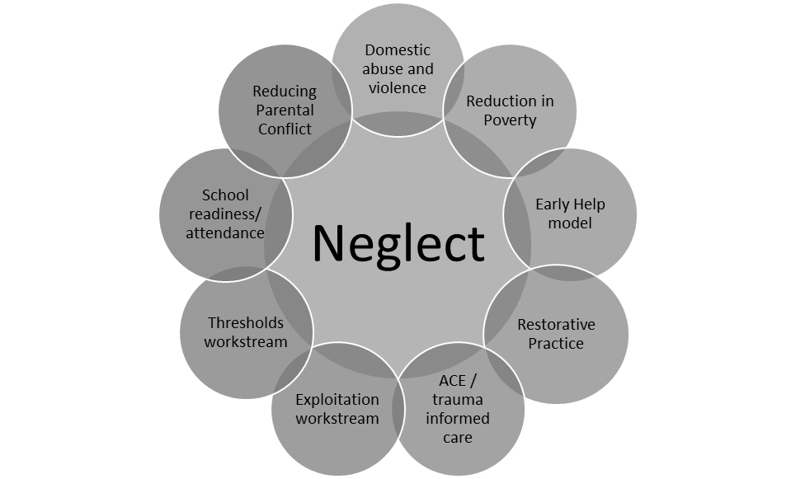
Priority 2: Improve awareness, understanding and recognition of neglect
Bolton Safeguarding Children Partnership has already developed multiagency Neglect Awareness Training in Bolton which introduces various tools which can be used to support the early identification of neglect and provide a framework for capturing the lived experience of a child. Despite this, practitioners have told us that either they not aware of the available tools; the range of tools available are confusing and/ or some people lack confidence in how to use these. A multi-agency audit (2019) of ten children on a child protection plan for neglect in Bolton highlighted that assessment, the use of appropriate tools (include assessment of readiness/ ability to change) and analysis could be strengthened. The audit also highlighted that there were missed opportunities in strategy meetings to involve wider professionals to inform decision making around neglect.
There is a real opportunity in Bolton to agree and clarify the tools of choice to support the identification of neglect and to build these into a robust toolkit and training offer. This said, evidence by Daniels et al (2011) suggested that protocols and guidelines are not a sufficient spur to response. Human issues such as trust, relationships, communication, anxiety, fear and confidence all affect the willingness to act on concerns and there is very little evidence about the impact of training on outcomes for children. Therefore, in Bolton it will be essential to embed new restorative ways of working and consider the supervision of staff in order to support the effective implementation of this Neglect Strategy.

Priority 3: Reduce the cumulative impact of neglect

A recurring theme among serious case reviews that identify good practice around neglect is the importance of the quality of relationships with families and the development of a sound grasp of the family context (Brandon et al 2020). The same review also highlighted many examples of unfocused interventions across the range of agencies which often used practical support to improve conditions rather than focusing on the long- term presenting needs of children – this resulted in ineffectual practice and drift.

There is a need to agree what a good response to neglect would look like for Bolton’s children across the continuum of need using evidence-based practice. We also must consider children with specific needs i.e. young people who continue to experience neglect in adolescence and those who continue to live with the impact of neglect from early childhood (Brandon et al 2020); children who are obese which may or may not be due to neglect considering the findings from the Manchester SCR around Child F (2018) and children living in poverty as Brandon et al (2020) noted that issues related to poverty were often dealt with on an ad hoc basis/ were incident driven and rarely was the impact on children or underlying cause addressed.

Good attendance at school is one of the most important factors in ensuring children and young people maximise life chances. The more time children spend together in an education setting the more chance they have of making friends, feeling included, boosting social skills, confidence and self-esteem. COVID19 has had a significant impact on the education and social interaction for our children. School plays a vital role in identifying and protecting children who are experiencing problems at home. Keeping children in school is essential. In Bolton, there needs to be a continued commitment to promoting school attendance and wellbeing within school.

11.0 What will success look like in Bolton?
In Bolton we believe that in order to tackle neglect, we need to change our language and strengthen the way we work with parents who may be unable to meet the needs of their children for some, or all of the time.

In Bolton our success will be measured by:
- Feedback from children, young people and parents which identifies improvements in their lived experience.
- Feedback from practitioners that they have more confidence to address neglect openly and transparently with families.
- Clarity about which tools to use to support the early identification of neglect and reported practitioner confidence in using these.
- Greater understanding of the prevalence of neglect which will be achieved through the development of mechanisms to record neglect/ needs attributable to neglect within Early Help assessments and child in need plans and through the layering of this with other information such as deprivation/ poverty data.
- Clear and robust thresholds when responding to neglect as identified within the Bolton Framework for Help and Support.
- Increased awareness of neglect resulting in breaking down the stigma of neglect across communities.
- Clear identification of positive ways to work with families in order to improve outcomes where neglect has been identified.

Specific Data:

- Reduction in the number of children subject to a Child Protection Plan under the category of neglect for a second or subsequent time.
- An increase in school attendance.
- An increase in the % of five-year olds achieving a good level of development in the Early Years Foundation Stage.

The neglect data set will be developed further throughout the time period of this strategy. These measures will be challenging to achieve due to the impact of COVID 19 however the Bolton Safeguarding Children Partnership will aim to review emerging themes and trends and respond accordingly.

Bolton Neglect Strategy 2020- 2023
No opportunity is missed and no opportunity is ignored to respond to child neglect
Strategic Commitment to Tackle Neglect Across All Partners | Improve Awareness, Understanding and Recognition of Neglect | Reduce the Cumulative Impact of Neglect
- Neglect is a priority for the Bolton Safeguarding Children Partnership  - Refresh of Neglect Strategy with Multi Agency sign up  - Develop arrangements to quality assure impact and effectiveness of arrangements to safeguard children from neglect  - Develop mechanisms for gathering effective data/ information to enable us to understand the prevalence of neglect in Bolton  - Ensure oversight and linkage to other work programmes which have strong interconnection to neglect | - Engagement with young people to better understand the impact of neglect and what works  - Agree how we will assess neglect using an ecological model across the age spectrum in Bolton.  - Ensure clarity and understanding around information sharing/ use of strategy meetings in relation to neglect | - Based on evidence and local good practice agree what good responses/ interventions for neglect would look like in Bolton for each level of the continuum of need and for children of difference ages  - Consider interventions for specific groups of children and young people i.e. teenagers, children with disabilities, families living in poverty, children who are obese, children living with the impact of neglect from early childhood, medical neglect.  - Consider strategies to improve school attendance within the Neglect Toolkit  - Raise awareness of local service provision which supports children and families earlier
- Revise Bolton’s neglect toolkit
- Refresh Bolton’s neglect training based on revised toolkit
- Launch toolkit at a Bolton wide neglect event (2021)
- Develop and launch community information around neglect (2021)

- Revise Bolton’s neglect toolkit
- Refresh Bolton’s neglect training based on revised toolkit
- Launch toolkit at a Bolton wide neglect event (2021)
- Develop and launch community information around neglect (2021)
Underpinned by: Early Help – clear thresholds which are understood by all - restorative practice – ACE awareness/ trauma attuned
- Revise the Bolton Neglect Tool kit
- Refresh the neglect training based on the revised toolkit
- Multi – agency neglect event to launch revised toolkit
- Communications within the community

Appendix 1: Ways in which children and young people can experience neglect
Experiences of neglect by age group; please note that the examples listed are intended to give an overview of what children may experience rather than provide an exhaustive list of ways in which neglect may present.

Age group | Medical | Nutritional | Emotional | Educational | Physical | Lack of supervision
Infancy;  0-2 years | Includes failure to notice that a baby is unwell, and failure to seek medical treatment. Not attending routine health screening appointments may be indicative. | Under-nourishment leads to restricted growth and brain development.  There can be a link between neglect and obesity, e.g. if parents use sweets as ‘pacifiers’. | Lack of stimulation can prevent babies from ‘fixing’ neural connections. Infant attachments are damaged by neglect, which makes learning skills more difficult | Some parts of the brain,  e.g. cortex, are dependent on experience and stimulation to develop. Language relies on reinforcement and feedback from carers. | Dirty home conditions may affect infant immune system; lack of changing and nappy rash; lack of encouragement may delay skill development. | Babies should be supervised at all times, particularly when lying on surfaces they could fall from or in the bath. If babies feel abandoned, this can affect the development of attachments.
Pre-school;  2-4 years | May include missed health and dental appointments, and failure to seek medical treatment following accidents or for routine conditions such as head lice or squints. | Not eating 1200 – 1500 calories per day, and/or unregulated amounts of fat and sugar in the diet, which can lead to heart problems, obesity and tooth decay | Neglected children without a secure attachment may experience difficulties playing with their peers, sharing feelings and thoughts, coping with frustration and developing empathy. | Neglect can be a significant factor in delaying a child’s language development  e.g. through the amount and quality of interactions with carers. This delay affects their education. | Child may present as dirty or malnourished, and living conditions may be poor. Child may not have been toilet trained, sleeping sufficiently or have adequate boundaries. | Home may lack safety devices e.g. stair gates, dangerous items such as drugs or knives may be within reach, child may not have appropriate car seat, child may be left home alone.
Primary;  5-11 years | Children may have more infections and illnesses than their peers due to poor treatment, or lack of prevention e.g. through hand washing, good diet or adequate sleep. | Food isn’t provided consistently, leading to unregulated diets of biscuits and sweets.  Concerns should not just focus on weight; children of normal weight could still have unhealthy diets. | Insecure attachment styles can lead to children having difficulties forming relationships, and may express their frustration at not having friends through disruptive behaviour. | Neglected children can experience a number of disadvantages at school, including low educational aspirations, lack of encouragement for learning and language stimulation. | Ill-fitting, inadequate or dirty clothing, poor personal hygiene, lack of sleep, lack of routines or boundaries which can lead to frustration with school rules and boundaries. | Primary school children may be left home alone after school, or expected to supervise younger children. They may be left to play outside alone or to cook meals without supervision.
Adolescent;  12+ years | Poor self-esteem and recklessness can lead to ignoring or enduring health problems rather than accessing services. There may also be risk- taking behaviour e.g. in sexual activity. | Adolescents may be able to find food, but lack of nutritious food and limited cooking experience can lead them to unhealthy snacks, which affects both health and educational outcomes. | Peer groups and independence are important at this age; young people who are isolated by neglect (e.g. through poor hygiene) will struggle. Conflict with carers may also increase. | Likely to experience cognitive impairment e.g. in managing emotion, challenging behaviour in school. Low confidence and academic failure can reinforce negative self- image. | Adolescents’ social development is likely to be affected by their living conditions, inadequate clothing, poor hygiene and body odour. This can affect their self- esteem. | Neglected adolescents may stay out all night with carers not aware of their whereabouts, which can lead to opportunities for risk-taking behaviours that can result in serious injury.
(Source: Community Care Inform Research Resource, Horwath)

HM Government (2018) Working Together to Safeguard Children. A guide to inter-agency working to safeguard and promote the welfare of children
Horwarth J (2007) Child Neglect: Identification and Assessment, Jan Horwath, Basingstoke, Palgrave Macmillan, Cited in many documents
Lancashire Multiagency Neglect Strategy 2019-2021 http://www.lancashiresafeguarding.org.uk/news/neglect-strategy.aspx
DFE (2020) Complexity and challenge: a triennial analysis of SCRs 2014-2017. Brandon et al
Ellis W and Dietz W (2017) A New Framework for Addressing Adverse Childhood and Community Experiences: The Building Community Resilience Model.
University of Sterling (2013) Action on Neglect – A Resource Pack https://www.stir.ac.uk/media/schools/appliedsocialscience/Action%20on%20Neglect.pdf
https://learning.nspcc.org.uk/research-resources/pre-2013/child-abuse-neglect-uk-today
https://library.nspcc.org.uk/HeritageScripts/Hapi.dll/retrieve2?SetID=EF142B52-6E01-472A-A2A0-1441BA8B03A7&searchterm=manchester%20&Fields=%40&Media=%23&Bool=AND&SearchPrecision=20&SortOrder=Y1&Offset=10&Direction=%2E&Dispfmt=F&Dispfmt_b=B27&Dispfmt_f=F13&DataSetName=LIVEDATA

